Analog Electronic Circuits – 2025-2026
Design Project Report

Group data
Group number | 05
Name – Student 1 | Béguelin Laurent
Name – Student 2 | Solo project.

Goal:
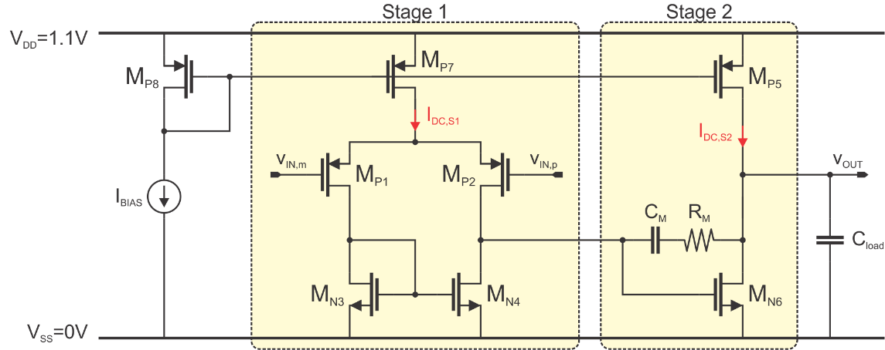
Design of the 2stage OpAmp such that it passes the given specifications (insert your specs below):
$$C_{load}[pF]$$ | 10
DC gain [dB] | 48
$f_{GBW}$ [MHz] | 80
Phase margin (PM) [deg] | > 70
Output swing [V] | > 0.7

Plan: Design of the 2-stage OpAmp on paper (10 points)

Calculate the $V_{OV}, g_{m},$ $I_{DS}$ and L of each transistor (see exceptions under “Remark”) and the required $C_{M}$ and $R_{M}$ in the OpAmp circuit. For that, insert all your calculations as well as your $\frac{g_{m}}{g_{ds}}$-, $\frac{g_{m}}{I_{D}}$-plots you used for your handcalculations below:
Hints:
- First, plot $\frac{g_{m}}{g_{ds}}$ and $\frac{g_{m}}{I_{D}}$ across $V_{OV}$ and gatelength L and do it again across $V_{GS}$, as presented in the 1st session. Think about whether to create the plots for a PMOS or for a NMOS device.
- Then, based on those plots, start your calculations.
- Furthermore, you can assume the following:
(1) the OpAmp is designed in triple-well-technology (i.e. $V_{SB}=0)$; (2) $V_{dsat}≈V_{OV}$ and $V_{dsat}≥50mV$ across $V_{OV}$; (3) $C_{M}=\frac{1}{4}⋅C_{L}$
Remarks:
- For Mp5, Mp7 and Mp8 you are not required to calculate the $g_{m}$
- All lengths should be between $60 nm$ and $1 μm$
- All widths should be between $1 μm$ and $1 mm$
- DC-voltage (common mode) at the input should be the same as the DC-voltage at the output

Plots used for the handcalculations:

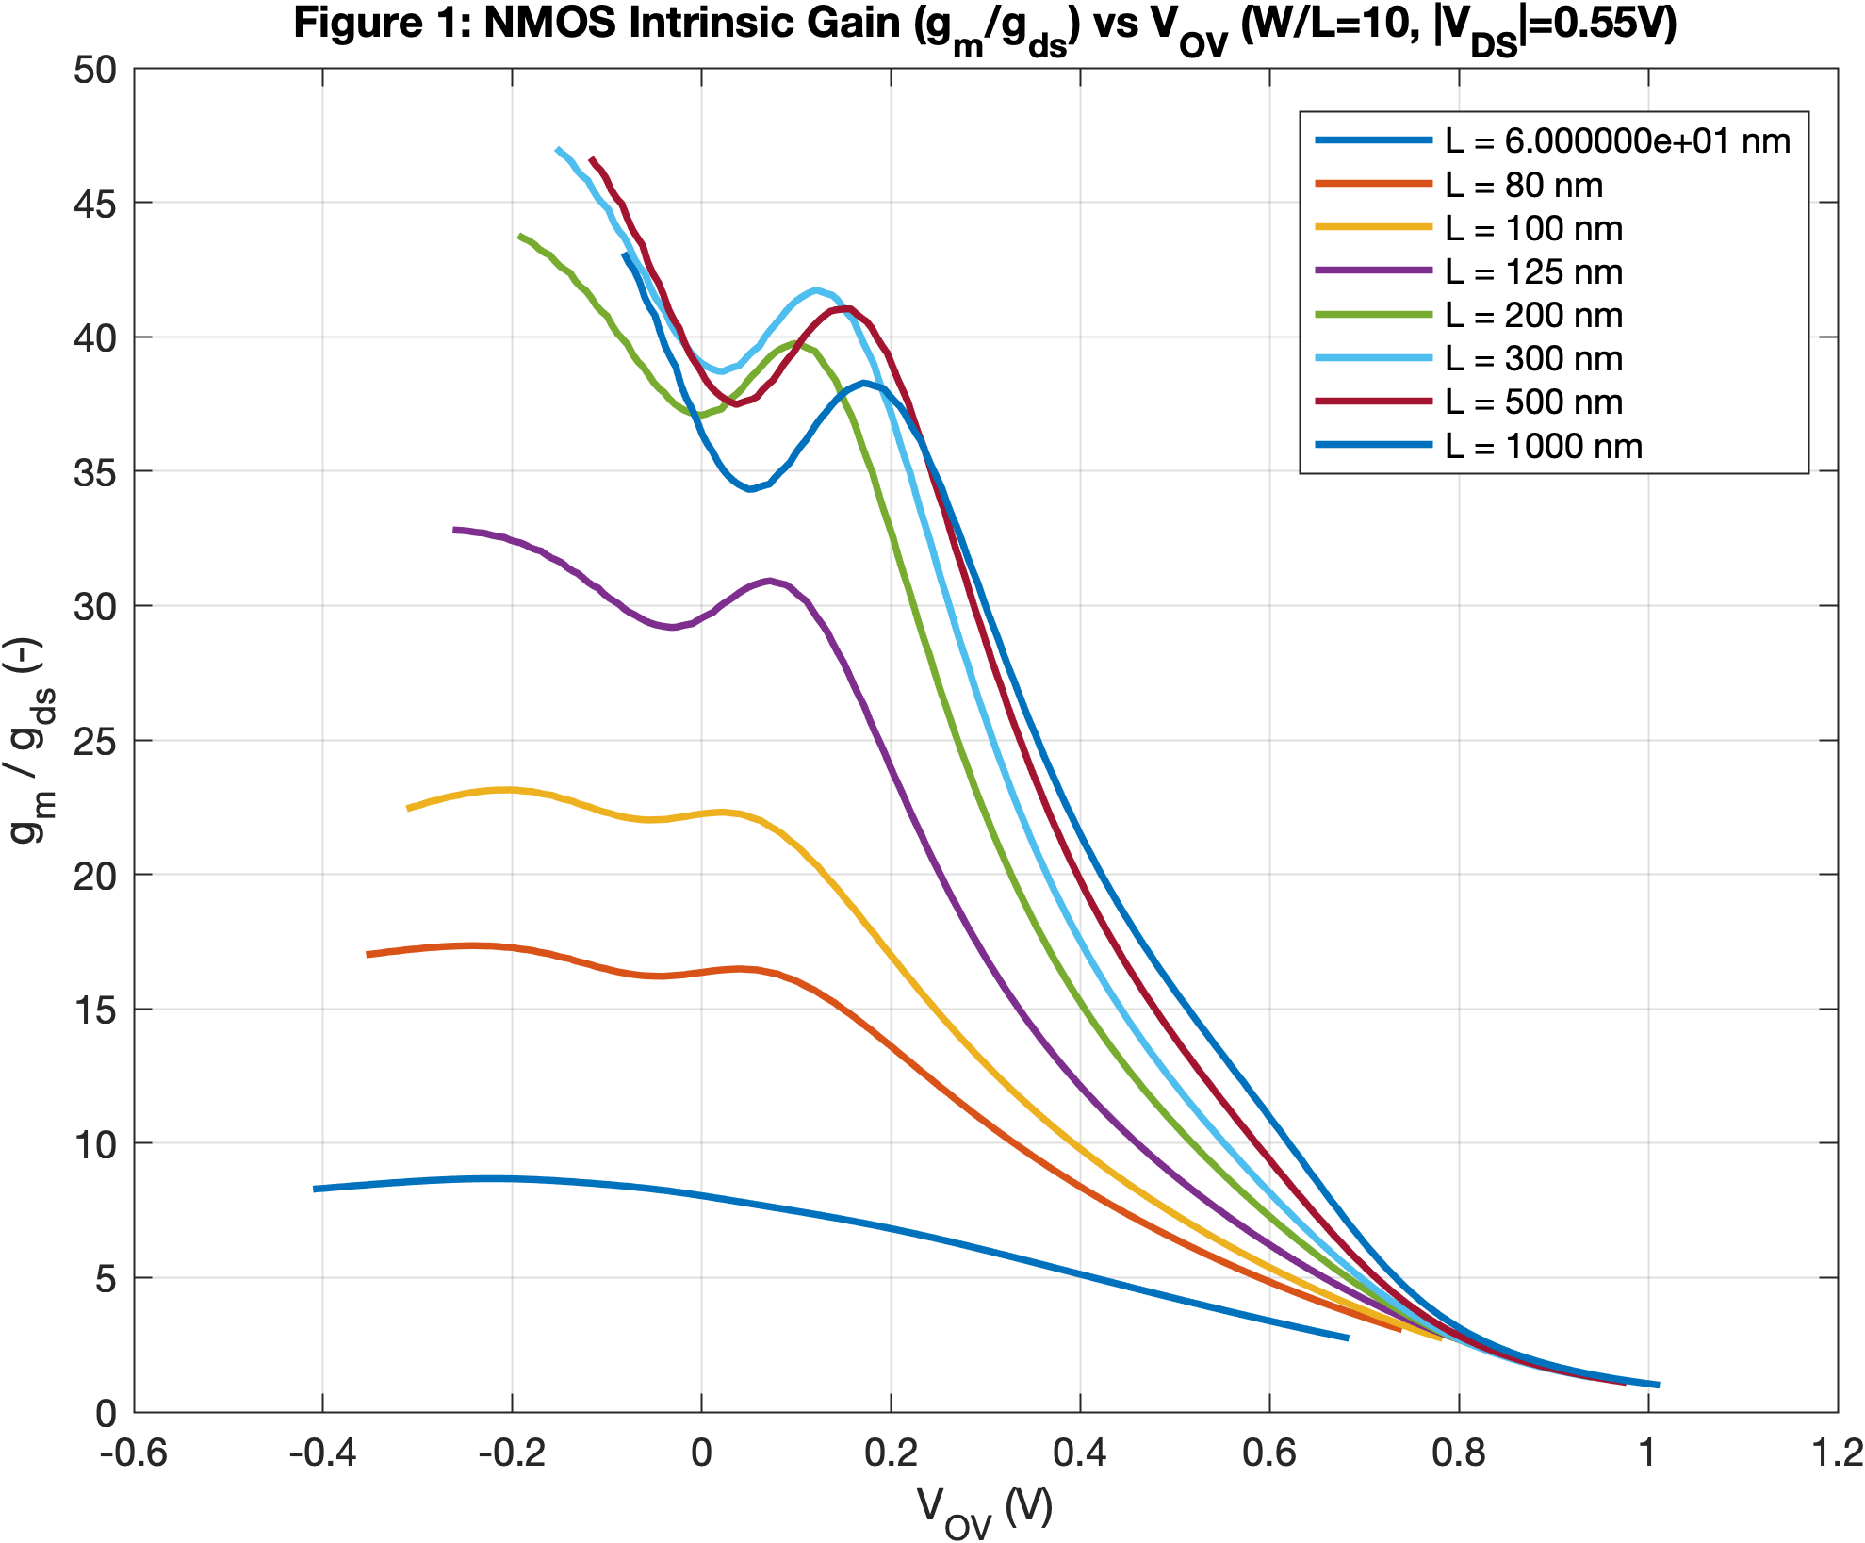

Figure 1: $\frac{g_{m}}{g_{ds}}$ vs $V_{OV}$ across gatelength $L ( NMOS)$

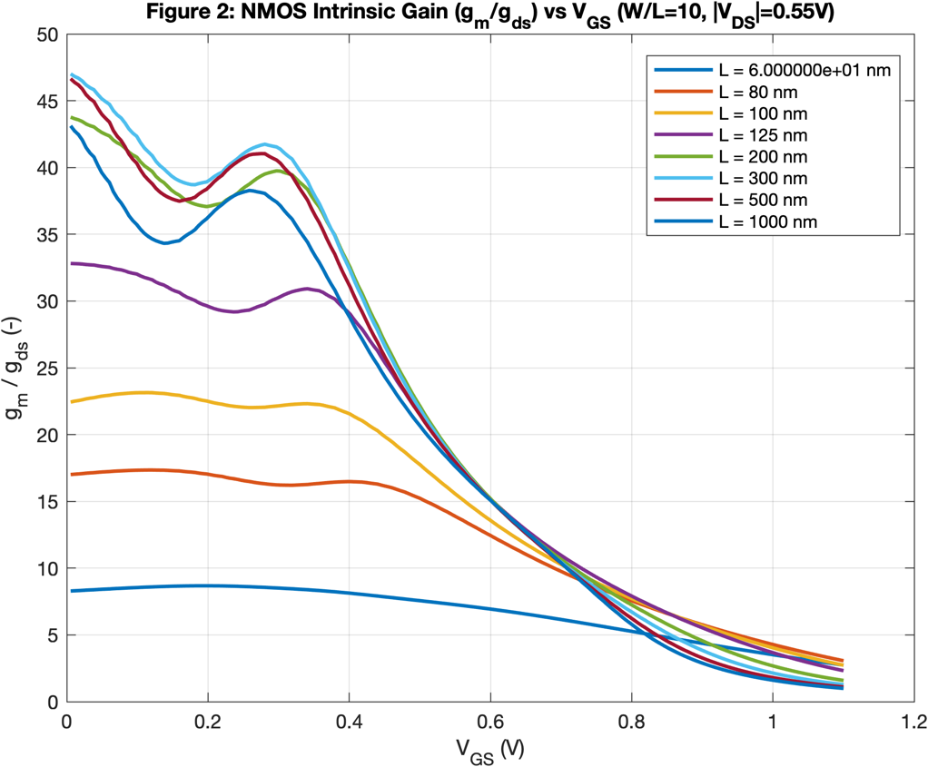

Figure 2: $\frac{g_{m}}{g_{ds}}$ vs $V_{GS}$ across gatelength $L(NMOS)$

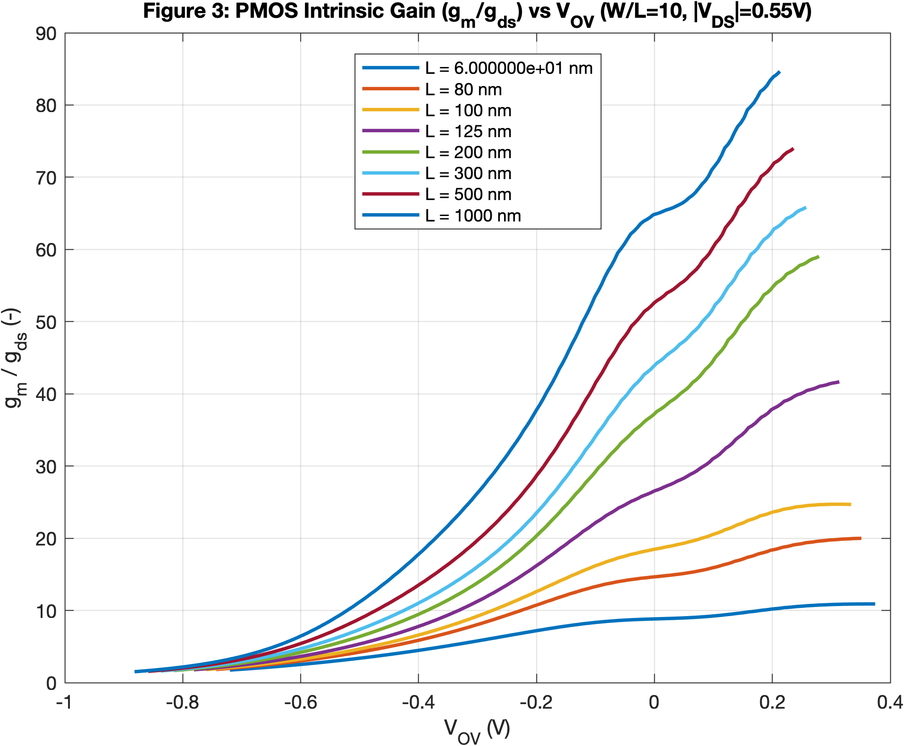

Figure 3: $\frac{g_{m}}{g_{ds}}$ vs $V_{OV}$ across gatelength $L(PMOS)$

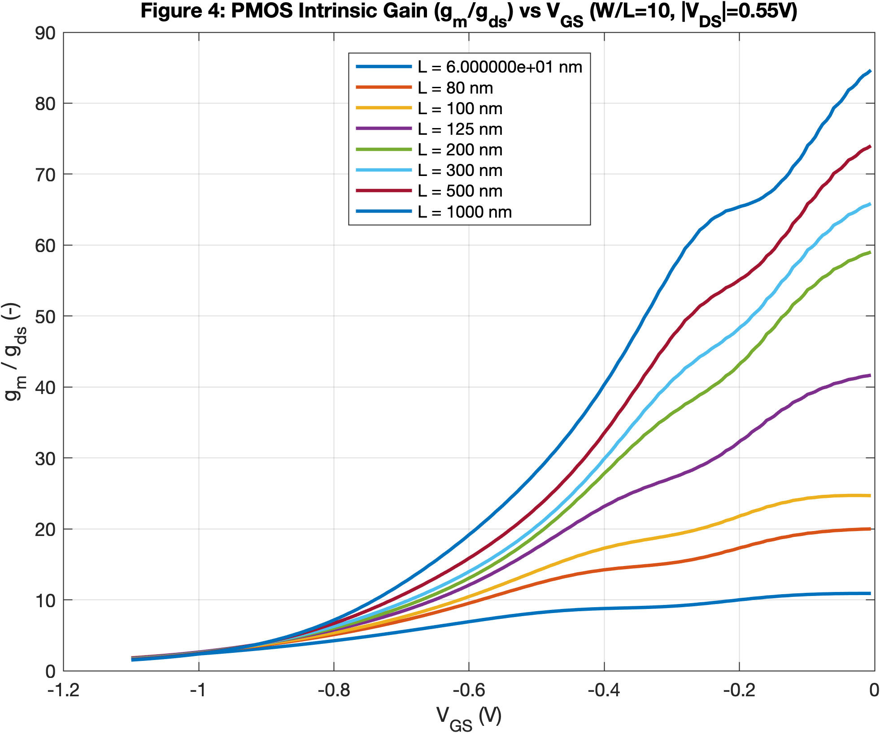
Figure 4: $\frac{g_{m}}{g_{ds}}$ vs $V_{GS}$ across gatelength $L(PMOS)$

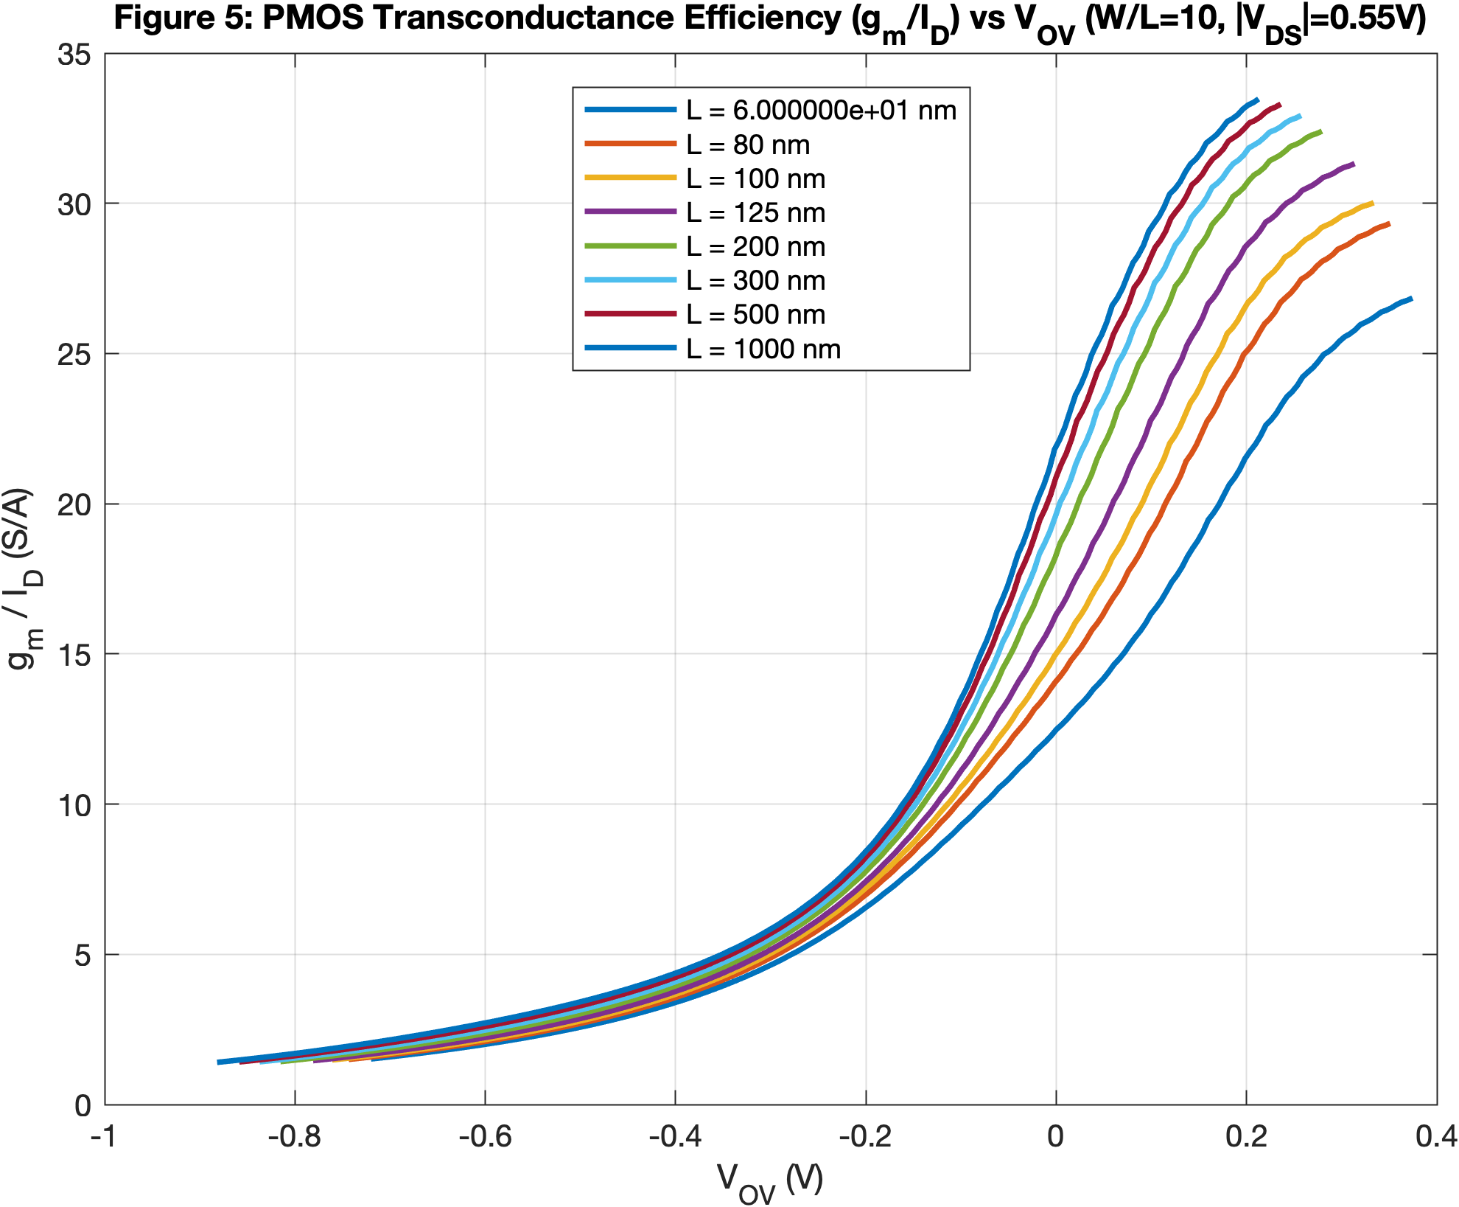
Figure 5: $\frac{g_{m}}{I_{D}}$ vs $V_{OV}$ across gatelength $L (PMOS)$

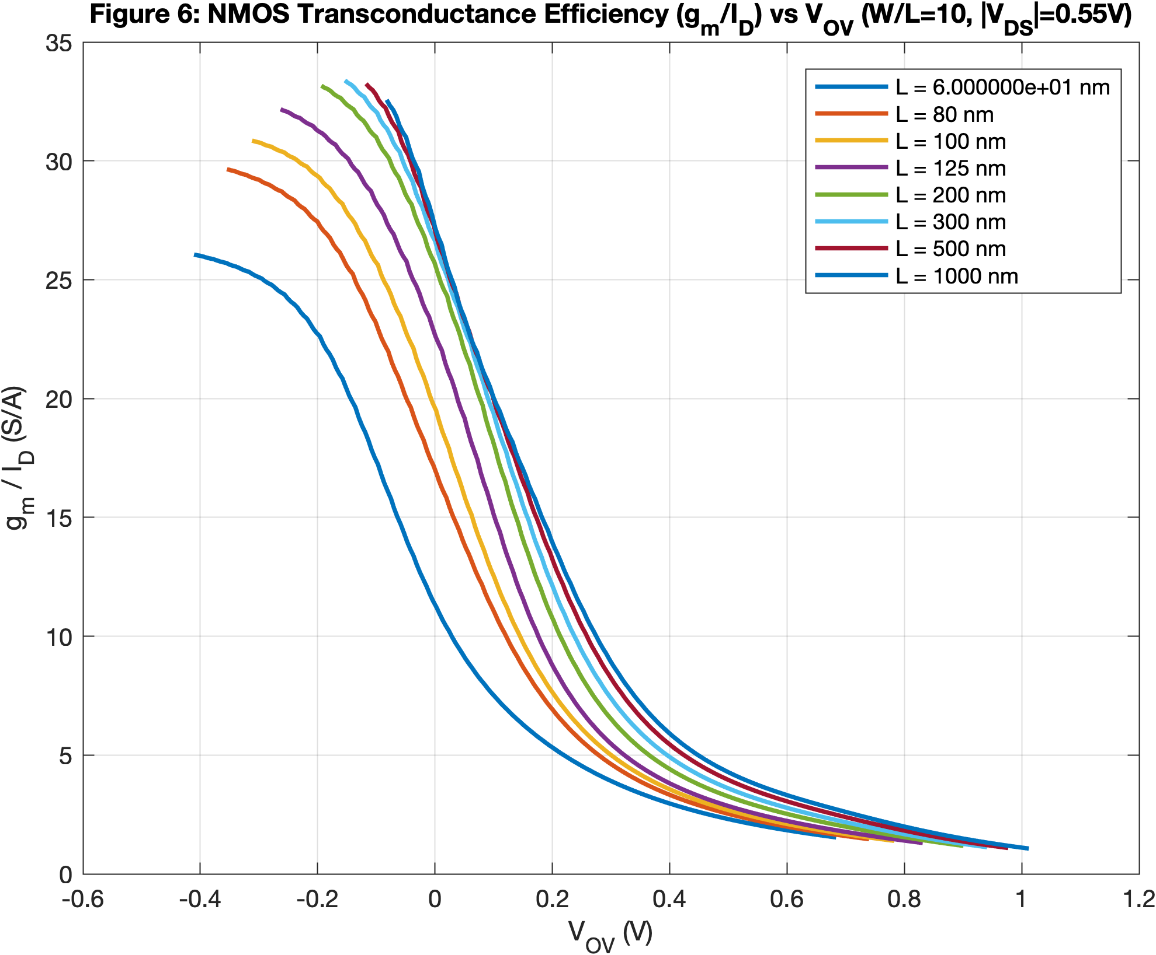
Figure 6 : $\frac{g_{m}}{I_{D}}$ vs $V_{OV}$ across gatelength $L (NMOS)$

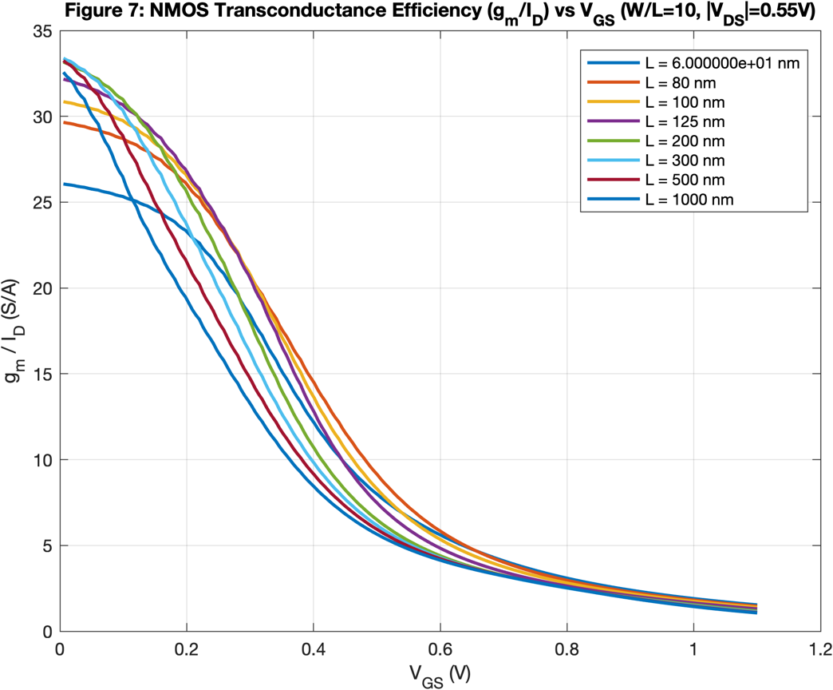
Figure 7 : $\frac{g_{m}}{I_{D}}$ vs $V_{GS}$ across gatelength $L (NMOS)$

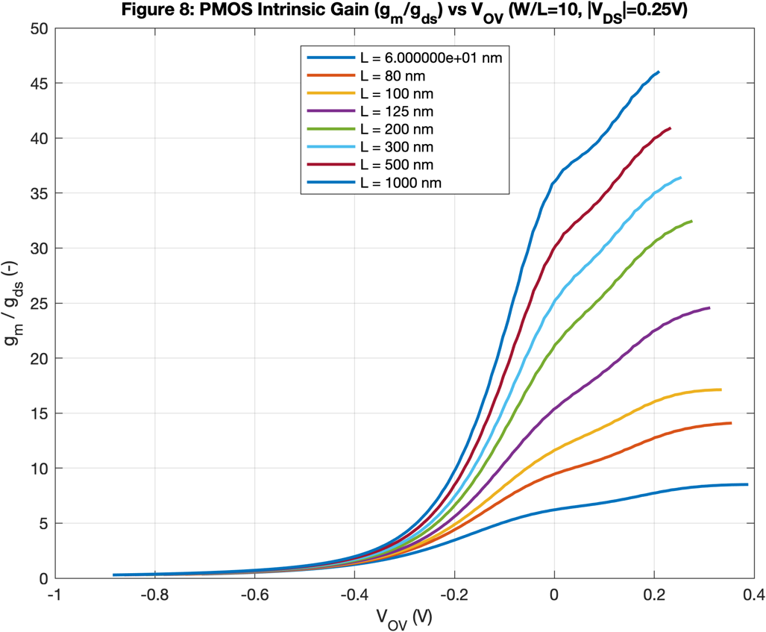
Figure 8: $\frac{g_{m}}{g_{ds}}$ vs $V_{GS}$ across gatelength $L\left(PMOS\right)with VDS=-0.25$

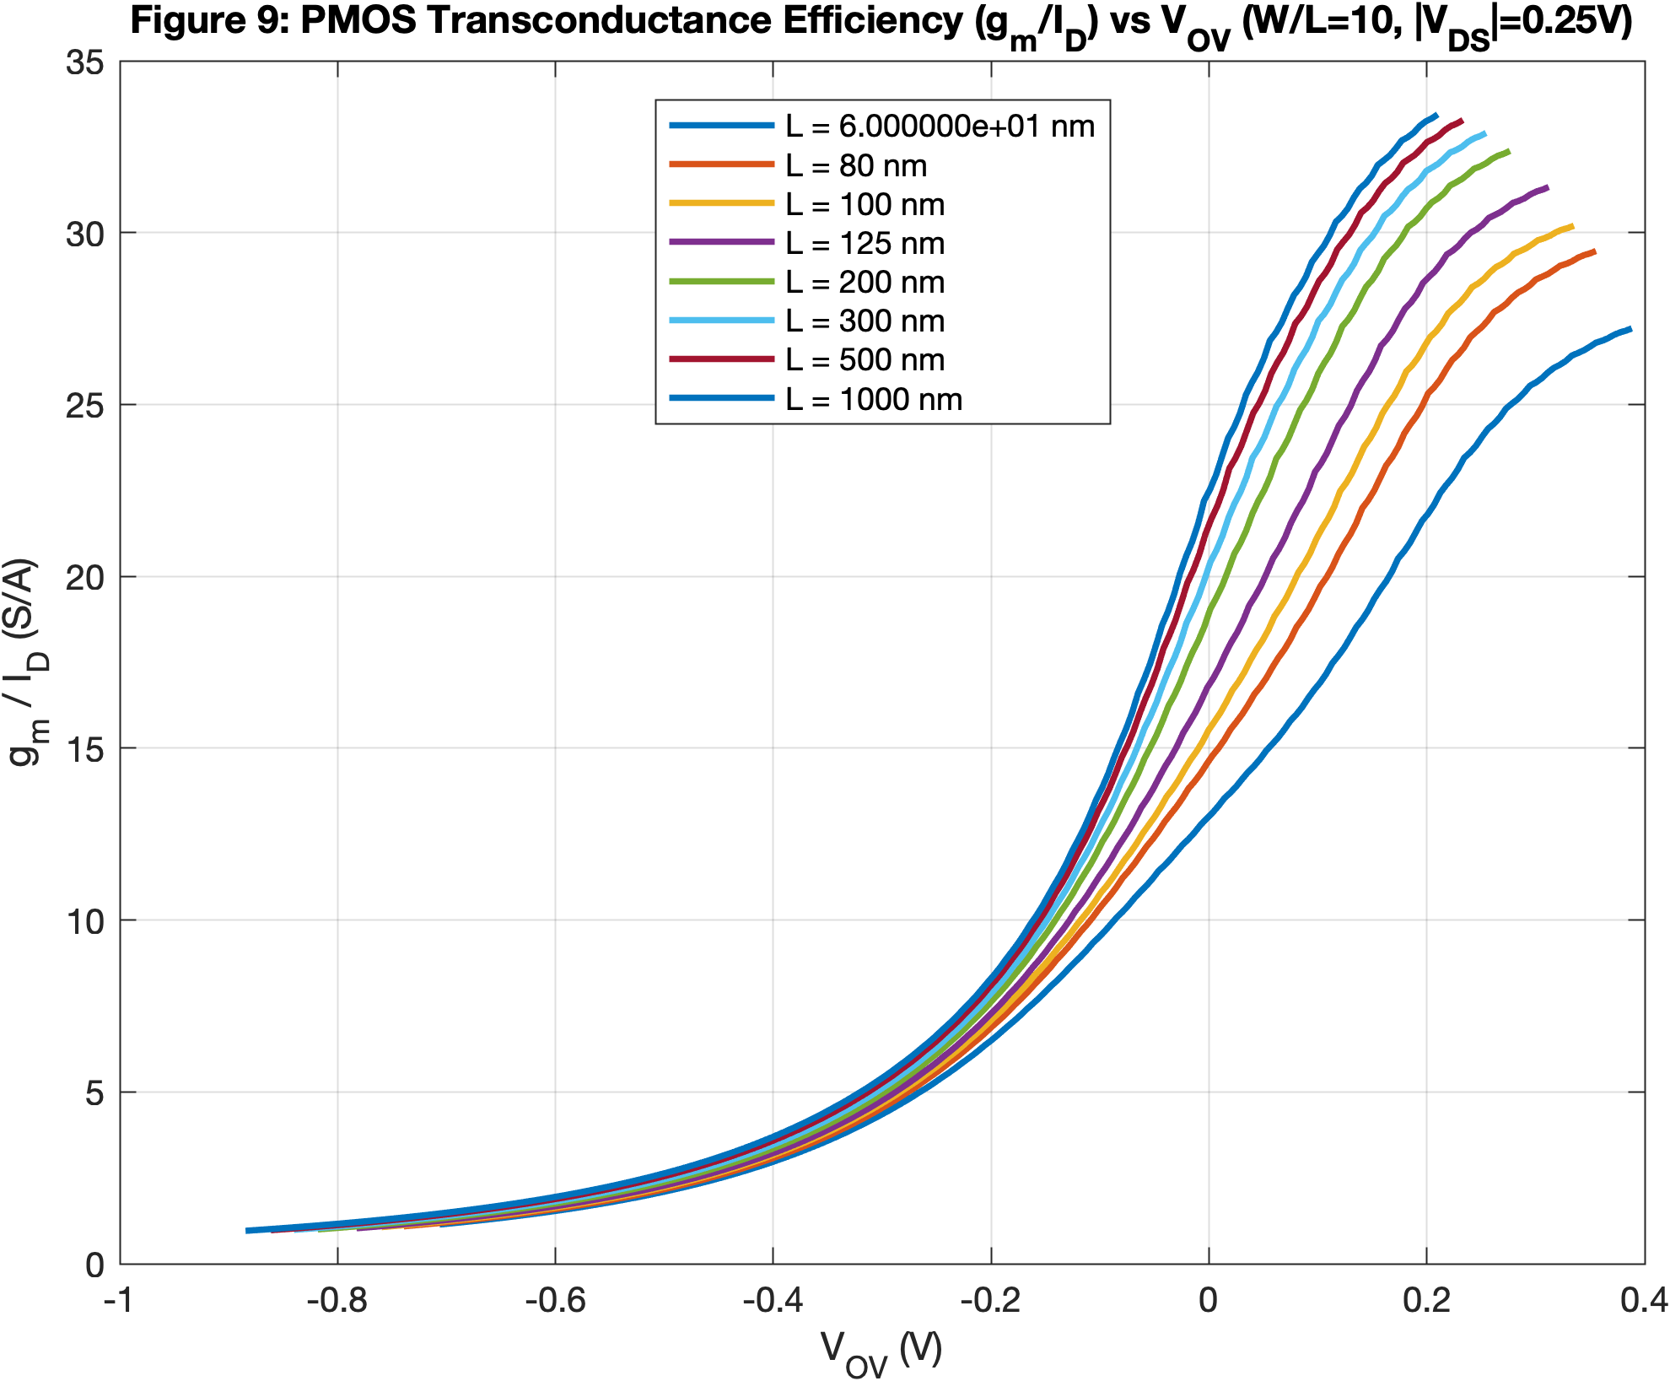
Figure 9: $\frac{g_{m}}{I_{D}}$ vs $V_{OV}$ across gatelength $L \left(PMOS\right)with VDS=-0.25$

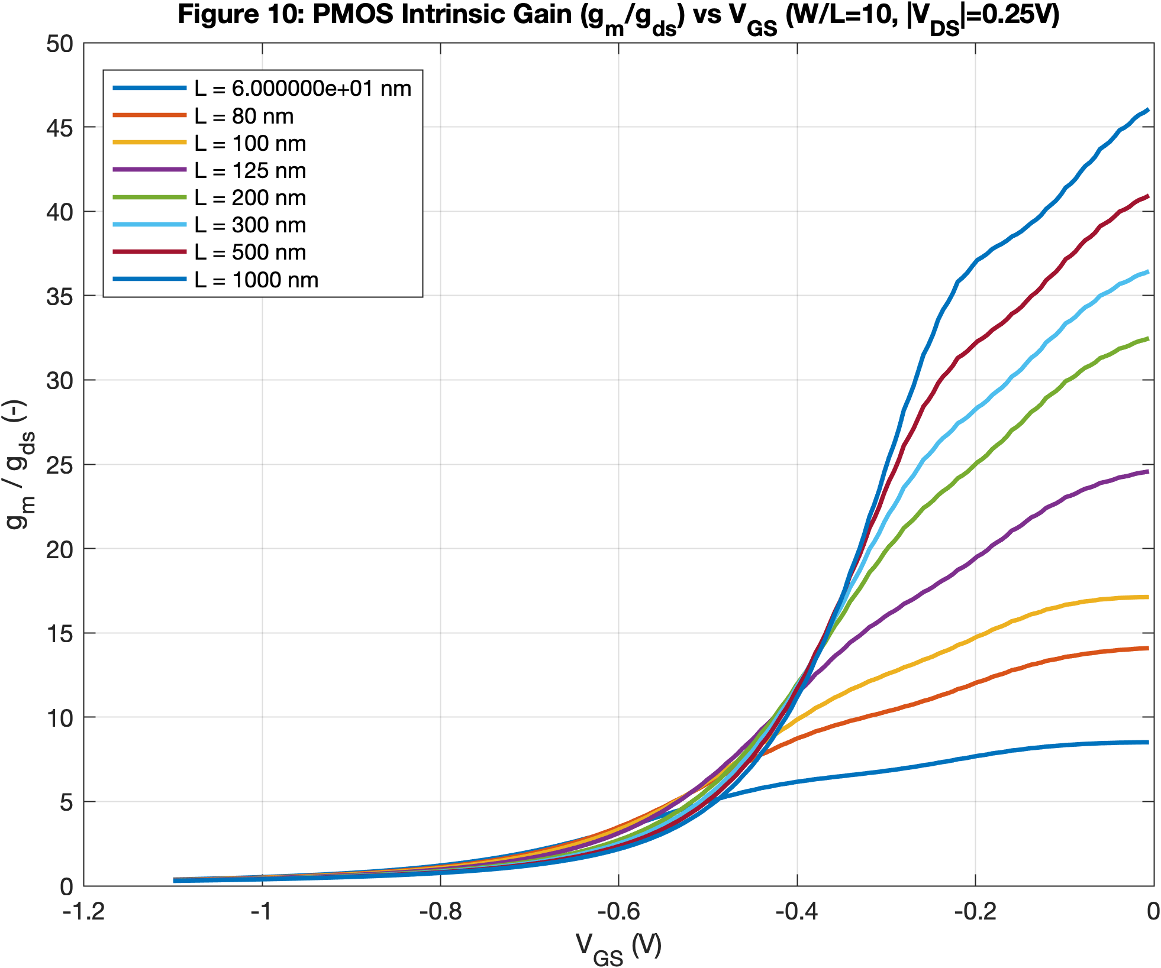

Figure 10: $\frac{g_{m}}{I_{D}}$ vs $V_{GS}$ across gatelength $L \left(PMOS\right)with VDS=-0.25$

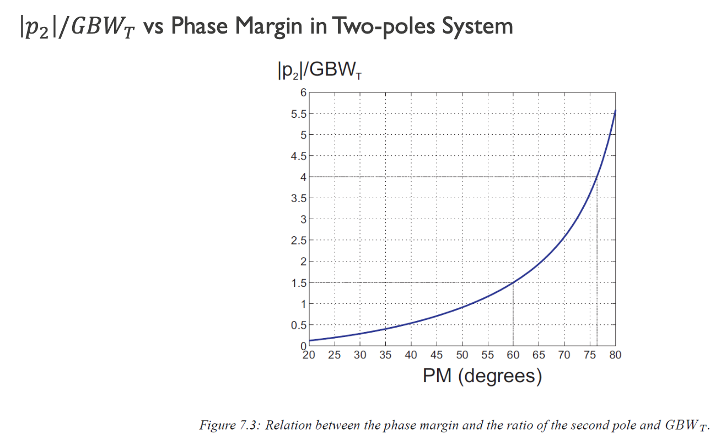

Figure 11 : $\frac{\left|p_{2}\right|}{GBW_{T}}$vs phase Margin (project reference).

1. System-Level Parameters
- Supply Voltage: $V_{DD}=1.1\text{ V}$
- Load Capacitance: $C_{L}=10\text{ pF}$
- Compensation Capacitance: Based on the design criteria, we set $C_{M}=\frac{1}{4}C_{L}$.
$$C_{M}=\frac{10\text{ pF}}{4}=2.5\text{ pF}$$
- Target Gain-Bandwidth Product: $f_{GBW}=80\text{ MHz}$
- Target Total Gain: $A_{v,\text{total}}=48\text{ dB}=251.2\text{ V/V}$

Methodology Note on $V_{DS}$ Selection :
To establish a baseline for the $g_{m}/I_{D}$ sizing methodology, the initial transistor characterization plots (Figures 1 through 7) were generated at a generic drain-to-source voltage of $|V_{DS}|=0.55\text{ V}$ like in the Labs slides. Extracting parameters at this midpoint provides a reliable, centralized baseline for intrinsic gain and transconductance efficiency across the saturation region. However, this generic assumption is intentionally overridden when the physical circuit topology strictly prohibits a $V_{DD}/2$ voltage drop. For instance, because the input pair ($M_{P1}$ and $M_{P2}$) is physically squeezed between the tail current source and the active load, its true $V_{DS}$ is heavily constrained. For those specific devices, targeted characterization data generated at $V_{DS}=-0.25\text{ V}$ (Figures 8 through 10) was used to ensures highly accurate $g_{ds}$ extraction without compromising the efficiency of the overall manual sizing process.

2. Output Stage (Stage 2) Sizing

Sizing the Output NMOS ($M_{N6}$)
The phase margin (PM) is directly influenced by the non-dominant pole ($f_{p2}$) created at the output. To a stable $PM>{70}^{∘}$, we must push this pole to a higher frequency relative to the GBW. Based on the two-pole system relationship from figure 6, we select a ratio of $\frac{f_{p2}}{f_{GBW}}=4.5$. ( a previous selection (3.5) lead to a PM of 68 due to parasitic capacitance, so this value ensure a computer result of >70°)
$$f_{p2}=4.5⋅f_{GBW}=4.5⋅80\text{ MHz}=360\text{ MHz}$$
The second pole is defined by the output transconductance and load capacitance:
$$g_{m6}=f_{p2}⋅2π⋅C_{L}=\left(360\text{ MHz}\right)⋅2π⋅\left(10\text{ pF}\right)=22.61\text{ mS}$$
To determine the required drain current ($I_{D6}$), we design $M_{N6}$ in moderate inversion. Selecting a channel length $L_{6}=125\text{ nm}$ and an overdrive voltage $V_{OV6}=0.1\text{ V}$, we extract the following parameters from the characterization plots:
- Transconductance Efficiency: $\frac{g_{m}}{I_{D}}=15.13\text{ S/A}$
- Intrinsic Gain: $\frac{g_{m}}{g_{ds}}=30.45$
From these readings, we calculate the bias current and output conductance:
$$I_{D6}=\frac{g_{m6}}{15.13}=\frac{22.61\text{ mS}}{15.13\text{ S/A}}=1.49\text{ mA}$$
$$g_{ds6}=\frac{g_{m6}}{30.45}=\frac{22.61\text{ mS}}{30.45}=0.74\text{ mS}$$

For the selected $L_{6}$ and $V_{OV6}$, the corresponding $V_{GS6}$obtained from the characterization plot( figures 2) is 0.371V

Sizing the PMOS Load ($M_{P5}$)
$M_{P5}$ acts as a current source active load for $M_{N6}$. Since they are in series, they share the same bias current:
$$I_{D5}=I_{D6}=1.49\text{ mA}$$
Selecting $L_{5}=500\text{ nm}$ and $V_{OV5}=-0.2\text{ V}$ to provide sufficient voltage headroom, we extract:
- Transconductance Efficiency: $\frac{g_{m}}{I_{D}}=8.28\text{ S/A}$
- Intrinsic Gain: $\frac{g_{m}}{g_{ds}}=28.8$
Calculating the parameters for $M_{P5}$:
$$g_{m5}=I_{D5}⋅8.28=1.49\text{ mA}⋅8.28\text{ S/A}=12.33\text{ mS}$$
$$g_{ds5}=\frac{g_{m5}}{28.8}=\frac{12.33\text{ mS}}{28.8}=0.428\text{ mS}$$

Stage 2 Voltage Gain (|$A_{v2}|$)
$$|A_{v2}|=\frac{g_{m6}}{g_{ds5}+g_{ds6}}=\frac{22.61\text{ mS}}{0.428\text{ mS}+0.74\text{ mS}}=19.3\text{ V/V}$$

3. Input Stage (Stage 1) Sizing

With the second stage contributing $A_{v2}=19.3\text{ V/V}$, the first stage must provide a minimum remaining gain of:
$$|A_{v1\text{,min}}|=\frac{A_{v,\text{total}}}{A_{v2}}=\frac{251.2\text{ V/V}}{19.35\text{ V/V}}=12.98\text{ V/V}$$

Sizing the Input PMOS Pair ($M_{P1},M_{P2}$)

The input transconductance is fixed by the $80\text{ MHz}$ Gain-Bandwidth Product (GBW) requirement, because the supply voltage is low and our gain of the 2nd is low too, we will use the non-approximate formula for gm1 :
$$f_{GBW}⋅2π⋅C_{M}=\left(80\text{ MHz}\right)⋅2π⋅\left(2.5\text{ pF}\right)=1.257\text{ mS}=1257 μ\text{S}$$

$$g_{m1}=f_{GBW}⋅2π⋅C_{M}⋅\left(\frac{1+{|A}_{v2}|}{{|A}_{v2}|}\right)$$
$$g_{m1}=1257 μ\text{S}⋅\left(\frac{20.35}{19.35}\right)= 1321 μ\text{S}$$
To achieve the necessary voltage gain while keeping power consumption low and minimizing output conductance, we select a long channel length $L_{1}=1000\text{ nm}$ and push the device closer to weak inversion with an overdrive voltage $V_{OV1}=-0.1\text{ V}$. From the characterization plots( figure 8 and 9):
- Transconductance Efficiency: $\frac{g_{m}}{I_{D}}=13.75\text{ S/A}$
- Intrinsic Gain: $\frac{g_{m}}{g_{ds}}=22.6$
Calculating the required bias current and output conductance per branch:
$$I_{D1}=I_{D2}=\frac{g_{m1}}{13.75}=\frac{1321 μ\text{S}}{13.75\text{ S/A}}=98 μ\text{A}$$
$$g_{ds1}=g_{ds2}=\frac{g_{m1}}{22.6}=\frac{1321 μ\text{S}}{22.6}=58.45 μ\text{S}$$

For the selected $L_{1}$ and $V_{OV1}$, the corresponding $V_{GS1}$obtained from the characterization plot( figures 10) is -0.313V.

Sizing the NMOS Active Load ($M_{N3},M_{N4}$)

The active load transistors are in series with the input pair and therefore carry the exact same branch current:
$$I_{D3}=I_{D4}=I_{D1}=I_{D2}=98 μ\text{A}$$

To maximize the first stage voltage gain, the output conductance of the active load ($g_{ds3}$) must be minimized. We force the NMOS deep into strong inversion to lower its transconductance efficiency. Selecting $L_{3}=1000\text{ nm}$and $V_{OV3}=0.35\text{ V}$, we extract the following from the plots:
- Transconductance Efficiency: $\frac{g_{m}}{I_{D}}=7.12\text{ S/A}$
- Intrinsic Gain: $\frac{g_{m}}{g_{ds}}=25.233$
Calculating the parameters for $M_{N3}$:
$$g_{m3}=I_{D3}⋅7.12=98.28 μ\text{A}⋅7.12\text{ S/A}=699.75 μ\text{S}$$
$$g_{ds3}=\frac{g_{m3}}{25.233}=\frac{699.75 μ\text{S}}{25.233}=27.73 μ\text{S}$$

For the selected $L_{3}$ and $V_{OV3}$, the corresponding $V_{GS3}$obtained from the characterization plot( figures 2) is 0.44V

Final Stage 1 Gain Verification
With the precise conductances calculated, we verify the final voltage gain of the first stage:
$${|A}_{v1}|=\frac{g_{m1}}{g_{ds1}+g_{ds3}}=\frac{1321 μ\text{S}}{58.45 μ\text{S}+27.73 μ\text{S}}=\frac{1321}{86.18}=15.32\text{ V/V}$$

This configuration successfully exceeds the $13\text{ V/V}$ minimum requirement. The total amplifier gain is now:
$$A_{v,\text{total}}=|A_{v1}|⋅|A_{v2}|=15.3⋅19.3=295\text{ V/V}=49\text{ dB}$$
This comfortably satisfies the $48\text{ dB}$ total gain specification.
We can note that the 1st stage gain is smaller than the 2nd stage, due mainly to the $f_{GBW}$, phase margin (PM), and Length ( L) Constrains. Although many textbook designs allocate a larger gain to the first stage to minimize the contribution of the second-stage noise, the gains obtained here (approximately 15 V/V and 19 V/V) remain relatively close. Since the project specifies no noise target and the simulated noise performance is acceptable, this gain distribution represents a reasonable engineering compromise.

4. Sizing the Biasing Network, Current Mirrors ($M_{P7},M_{P8}$)

The PMOS transistor $M_{P7}$ acts as the tail current source for the first stage. It must supply the combined current for both branches of the differential pair:
$$I_{D7}=I_{D1}+I_{D2}=2⋅98 μ\text{A}=196 μ\text{A}$$
For the reference branch ($M_{P8}$), we select a sufficiently small bias current to minimize the overall static power dissipation of the amplifier:
$$I_{BIAS}=I_{D8}=196 μ\text{A}$$

Shared Mirror Parameters ($L$ and $V_{OV}$)

To ensures accurate current mirroring and excellent matching across the entire biasing network, all three PMOS current source transistors ($M_{P5},M_{P7},M_{P8}$) are designed with identical channel lengths and overdrive voltages. This suppresses channel-length modulation mismatches between the reference and the mirrored branches:
- Channel Lengths: $L_{5}=L_{7}=L_{8}=500\text{ nm}$
- Overdrive Voltages: $V_{OV5}=V_{OV7}=V_{OV8}=-0.2\text{ V}$
For the selected $L_{5}$ and $V_{OV5}$, the corresponding $V_{GS5}$obtained from the characterization plot( figures 4) is -0.44V

5. Frequency Analysis: Poles, Zeros, and Compensation

To verify the frequency behavior and guarantee a stable phase margin ($PM>{70}^{∘}$, targeting a solid ${75}^{∘}$), we evaluate the small-signal poles and zeros across each major node of the two-stage OpAmp.

Target Dominant Pole Frequency ($ω_{p,\text{dom}}$)
The dominant pole frequency is established by the required Gain-Bandwidth Product ($f_{GBW}=80\text{ MHz}$) and our calculated total DC gain ($A_{v,\text{total}}=295\text{ V/V}$):
$$f_{p,\text{dom}}=\frac{f_{GBW}}{A_{v,\text{total}}}=\frac{80\text{ MHz}}{295}=271.11\text{ kHz}$$
$$ω_{p,\text{dom}}=2π⋅f_{p,\text{dom}}=1.703\text{ Mrad/s}$$

Node-by-Node Pole Analysis

- Node 1 (Current Mirror Pole):
Located at the drain of $M_{P1}$ and the gates of the active load ($M_{N3},M_{N4}$):
$$ω_{p,1}=\frac{g_{m3}}{C_{n1}}$$
Because $C_{n1}$ consists purely of small internal parasitic capacitances ($C_{n1}=C_{gd1}+C_{db1}+2C_{gs3}+…$), $C_{n1}≪C_{L}$ and $C_{n1}≪C_{M}$. Consequently, $ω_{p,1}$ resides at an extremely high frequency and has a negligible impact on the phase margin.
- Node 2 (Dominant Pole):
Formed at the output of the first stage (input of $M_{N6}$) due to the Miller multiplication of $C_{M}$:
$$ω_{p,2}=\frac{g_{ds1}+g_{ds3}}{C_{M}\left(1+A_{v2}\right)}=\frac{58.45 μ\text{S}+27.73μ\text{S}}{2.5\text{ pF}⋅\left(1+19.3\right)}=1.698\text{ Mrad/s}$$

This places our dominant pole at 270.9kHz, multiplying by the gain we get
$$f_{GBW}=295⋅270.9\text{ kHz}=79.9\text{ MHz}$$
- Node 3 (Non-Dominant Output Pole):
The non-dominant pole is located at the output node, where the total capacitance consists of the load capacitance ($C_{L}$) and the compensation capacitor ($C_{M}$) :
$$ω_{p3}=\frac{g_{ds5}+g_{ds6}}{C_{L}+C_{M}}$$
Under the assumption that the second-stage gain is sufficiently large ($g_{m6}≫g_{ds5}+g_{ds6}$), the pole is pushed outward, leading to :
$$ω_{p3}≈\frac{g_{m6}}{C_{L}+C_{M}}$$
Given that our compensation capacitor ($C_{M}=2.5\text{ pF}$) is notably smaller than the load capacitance ($C_{L}=10\text{ pF}$), this reduces the equation to ( in the book chapter 8 equation 8.55) :
$$ω_{p3}≈\frac{g_{m6}}{C_{L}}$$

Substituting our calculated values into this expression provides the pole frequency in radians per second:
$$ω_{p3}≈\frac{22.61\text{ mS}}{10\text{ pF}}=2.261×{10}^{9}\text{ rad/s}$$
Or equivalently, in Hertz:
$$f_{p3}=\frac{ω_{p3}}{2π}=360\text{ MHz}$$
This confirms that the non-dominant pole is placed at approximately 4.5 times the target gain-bandwidth product of 80 MHz, which provides the desired phase margin for system stability.

Zero Compensation and Nulling Resistor ($R_{M}$)

Without compensation, the Miller capacitor creates a Right-Half Plane (RHP) zero that introduces positive phase lag, severely degrading the phase margin:
$$ω_{z,2,\text{uncompensated}}=+\frac{g_{m6}}{C_{M}}$$
To eliminate this effect and lock in our target Phase Margin, we insert a nulling resistor ($R_{M}$) in series with $C_{M}$. The exact value required to push the zero into the Left-Half Plane (LHP) and place it directly on top of the non-dominant pole ($ω_{z,2}=ω_{p,3}$) is calculated as:
$$R_{M}=\frac{1}{g_{m6}}\left(1+\frac{C_{L}}{C_{M}}\right)$$
$$R_{M}=\frac{1}{0.0226\text{ S}}\left(1+\frac{10\text{ pF}}{2.5\text{ pF}}\right)=44.23⋅5=221 Ω$$

Verification of Compensated Zero ($ω_{z,2}$)
Substituting $R_{M}=221 Ω$ back into the modified zero transfer function:
$$ω_{z,2}=\frac{1}{C_{M}\left(\frac{1}{g_{m6}}-R_{M}\right)}=\frac{1}{2.5\text{ pF}⋅\left(44.23 Ω-221 Ω\right)}=-2.26\text{ Grad/s}$$
The negative sign confirms that the zero has been shifted to the Left-Half Plane, and its magnitude precisely cancels the output pole at Node 3 ($ω_{p,3}=2.26\text{ Grad/s}$), ensuring robust stability and transient response.
Note for completeness( equations 8.56, book chapter 8) : While the insertion of the nulling resistor ($R_{M}$) introduces a third mathematical pole ($p_{3}≈-\frac{1}{R_{M}C_{n2}}$) due to the creation of an extra physical node, the parasitic capacitance at this node ($C_{n2}$) is so small that this pole is pushed to an ultra-high frequency well beyond our region of interest and is safely neglected in the phase margin calculation.
Phase Margin (PM) Calculation :
To verify theoretical stability without the nulling resistor ($R_{M}=0$), we evaluate the phase shifts at the unity-gain frequency ($f_{GBW}=80\text{ MHz}$) caused by the dominant pole ($f_{p2}=270.9\text{ kHz}$), the output pole ($f_{p3}=360\text{ MHz}$), and the uncompensated RHP zero ($f_{z,RHP}=1.44 \text{GHz}$):
$$PM={180}^{∘}-\tan^{-1}\left(\frac{f_{GBW}}{f_{p2}}\right)-\tan^{-1}\left(\frac{f_{GBW}}{f_{p3}}\right)-\tan^{-1}\left(\frac{f_{GBW}}{f_{z,RHP}}\right)$$
$$PM={180}^{∘}-\tan^{-1}\left(\frac{80}{0.2709}\right)-\tan^{-1}\left(\frac{80}{360}\right)-\tan^{-1}\left(\frac{80}{1440}\right)$$
$$PM={180}^{∘}-{89.8}^{∘}-{12.5}^{∘}-{3.1}^{∘}={74.6}^{∘}$$

This is a good value above the constrain PM >70°, needed because real-world parasitics and temperature variations will inevitably degrade it.
By adding the nulling resistor $R_{M}≠0$ ($221 Ω$), we move the zero into the Left-Half Plane to compensate and cancel the output pole ($f_{p3}$). This eliminates the ${15.9}^{∘}$ phase drop:
$$PM_{compensated}={180}^{∘}-\tan^{-1}\left(\frac{f_{GBW}}{f_{p2}}\right)≈{90}^{∘}$$
This provides a comfortable stability margin for the simulated operating conditions.

6. Output Voltage Swing

Minimum Output Voltage ($V_{out,min}$):
The output voltage cannot drop below the overdrive voltage of $M_{N6}$ without pushing it into the triode region.
$$V_{out,min}=V_{OV6}=0.1\text{ V}$$

Maximum Output Voltage ($V_{out,max}$):
The output voltage cannot rise higher than the supply voltage minus the absolute overdrive voltage of $M_{P5}$.
$$V_{out,max}=V_{DD}-|V_{OV5}|$$
$$V_{out,max}=1.1\text{ V}-|-0.2\text{ V}|=0.9\text{ V}$$
Total Output Swing:
$$\text{Output Swing}=V_{out,max}-V_{out,min}$$
$$\text{Output Swing}=0.9\text{ V}-0.1\text{ V}=0.8\text{ V}$$

Conclusion: The calculated output swing of $0.8\text{ V}$ successfully satisfies the project specification requiring an output swing of $>0.7\text{ V}$.
According to those limitation : i choose $V_{in,cm}=V_{out}$ = 0.5 V and IBias = 196$μA$ (smallest current of the circuit). This yield $V_{S1}=V_{in,cm}+|V_{GS1}|=0.5\text{ V}+0.313\text{ V}=0.813\text{ V}$

Place the obtained values in the table below. Only the values in here need to be calculated / chosen in the handcalculations. Each value should be chosen with a reason which you have to provide above.

Device | L  [nm] | I_{ds}  [μA] | V_{OV}  [V] | g_{m}  [$μ$S]
M_{p1} | 1000 | $98$ | -0.1 | $1321$
M_{p2} | 1000 | $98$ | -0.1 | $1321$
M_{n3} | 1000 | $98$ | 0.35 | 699
M_{n4} | 1000 | $98$ | 0.35 | 699
M_{p5} | 500 | 1490 | -0.2
M_{n6} | 125 | 1490 | 0.1 | 22610
M_{p7} | 500 | 196 | -0.2
M_{p8} | 500 | 20 | -0.2

Device | Units | Value
R_{M} | Ω | 221
I_{BIAS} | A | 0.000196

Place all the calculated voltages (in the black box) and all currents (in the red box) on the circuit depicted below and calculate also (include formula):

$$V_{cm,in,min}$$ | $$V_{GS,3}-V_{OV,1}+V_{GS,1}=0.44-\left(-0.1\right)-0.313=227mV$$
$$V_{cm,in,max}$$ | $$V_{DD}+V_{OV,7}+V_{GS,1}=1.1-0.2-0.313=587mV$$
$$V_{out,min}$$ | $V_{OV,6}=0.1$V
$$V_{out,max}$$ | $V_{DD}-|V_{OV,5}|=1.1-0.2=0.9$V
$$P_{diss}$$ | $V_{DD}\left(I_{DC,S1}+I_{DC,S2}+I_{BIAS}\right)=1.1\left(0.196+1.49+0.196\right)=2$mW


0.660V

196$μA$
196$μA$
1.49mA
0.371V
0.5V
0.44V
813mV

Design: Implementation of the OpAmp in MATLAB and LTspice (10 points):

Based on your handcalculations, create your OpAmp design in MATLAB.

Remarks:
- Please make sure that all widths W are below 1mm
- Don’t write your values calculated in the previous step as constants in MATLAB but write the full equation in your code.
- Values chosen as design choices should match between this table and the one from the handcalculations!
- Choose the Vin,cm as the DC output voltage (Mn6.vds)

Fill out both tables depicted below. All values are to be determined in MATLAB.

Device sizes and bias point parameters according to MATLAB
Device | W  [μm] | L  [nm] | I_{ds}  [μA] | V_{GS}  [V] | V_{OV}  [V] | g_{m}  [S] | g_{ds}  [S] | g_{m}/g_{ds}  [-] | V_{ds,sat}  [V] | V_{ds}  [V]
M_{p1} | 109.99 | 1000 | 101.19 | -0.315 | -0.1 | 1.39mS | 62.11uS | 22.3 | - 106.53mV | -0.25
M_{p2} | 109.99 | 1000 | 101.19 | -0.315 | -0.1 | 1.39mS | 62.11uS | 22.3 | - 106.53mV | -0.25
M_{n3} | 6.02 | 1000 | 101.19 | 0.438 | 0.35 | 727.3uS | 28.63uS | 25.40 | 227.67mV | 0.55
M_{n4} | 6.02 | 1000 | 101.19 | 0.438 | 0.35 | 727.3uS | 28.63uS | 25.40 | 227.67mV | 0.55
M_{p5} | 237.99 | 500 | 1560 | -0.442 | -0.2 |  | 416.56uS |  | -180.37mV | -0.55
M_{n6} | 77.94 | 125 | 1560 | 0.368 | 0.1 | 23.75mS | 824.51mS | 0.02 | 90.96mV | 0.5
M_{p7} | 31.46 | 500 | 202.37 | -0.441 | -0.2 |  | 58.14uS |  | -180.39mV | -0.55
M_{p8} | 30.47 | 500 | 196 | -0.441 | -0.2 |  | 56.31uS |  | -180.39mV | -0.55

Device | Units | Value
C_{M} | pF | 2.5
R_{M} | Ω | 210
I_{BIAS} | A | 0.000196
V_{in,cm} | V | 0.5

Based on the parameters filled in the table above, design your OpAmp in LTspice. The filled-in MATLAB template and final LTspice schematic should be included in your Canvas submission (read the assignment instructions on Canvas to see the full description of the files to include).

Experiment (10 points):
In this section you will simulate the following:
- Frequency Response in MATLAB and LTspice
- Noise contribution in LTspice
- Linearity in LTspice
Note on how to present graphs in general:
- When you make a graph, put labels on every axis to make clear what you are showing. Also, show the units!
- When you plot multiple curves on one graph, add a legend.

- Frequency Response in MATLAB and LTspice
Note on how to present graphs in this sub-section:
- For magnitude plots use dB (linear scale) vs. Hz (logarithmic scale)
- for phase plots use ° (linear scale) vs. Hz (logarithmic scale).

Simulate $A_{v}$ (small voltage gain) with $C_{M}$ and $R_{M}$ in MATLAB and LTspice. Then, paste both $A_{v}$-curves in separate plots below such that the difference between MATLAB and LTspice can be clearly seen. In addition to that, indicate the resulting phase margin (PM) in both plots.

Plots:

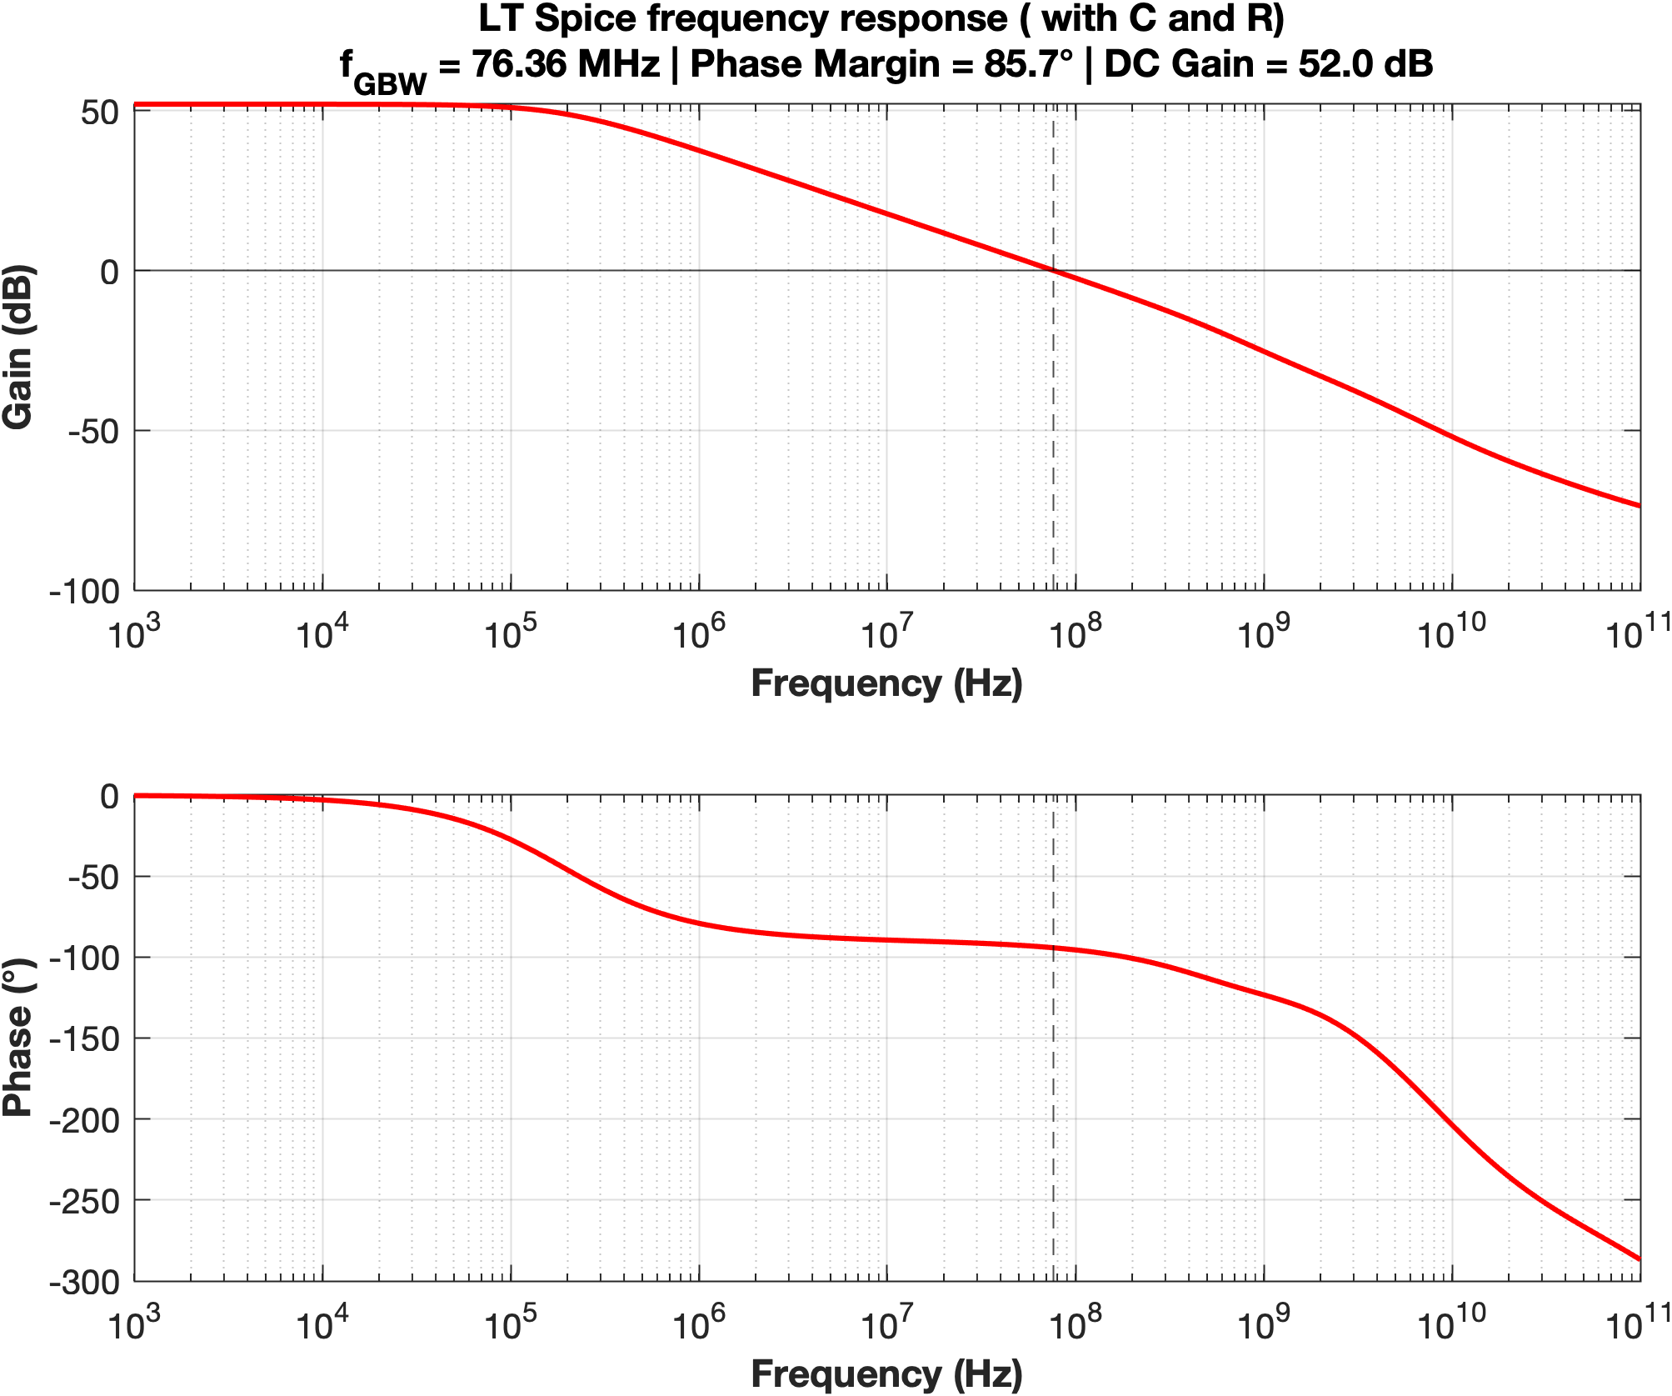

Figure 12: $Bode plot of LTspice$

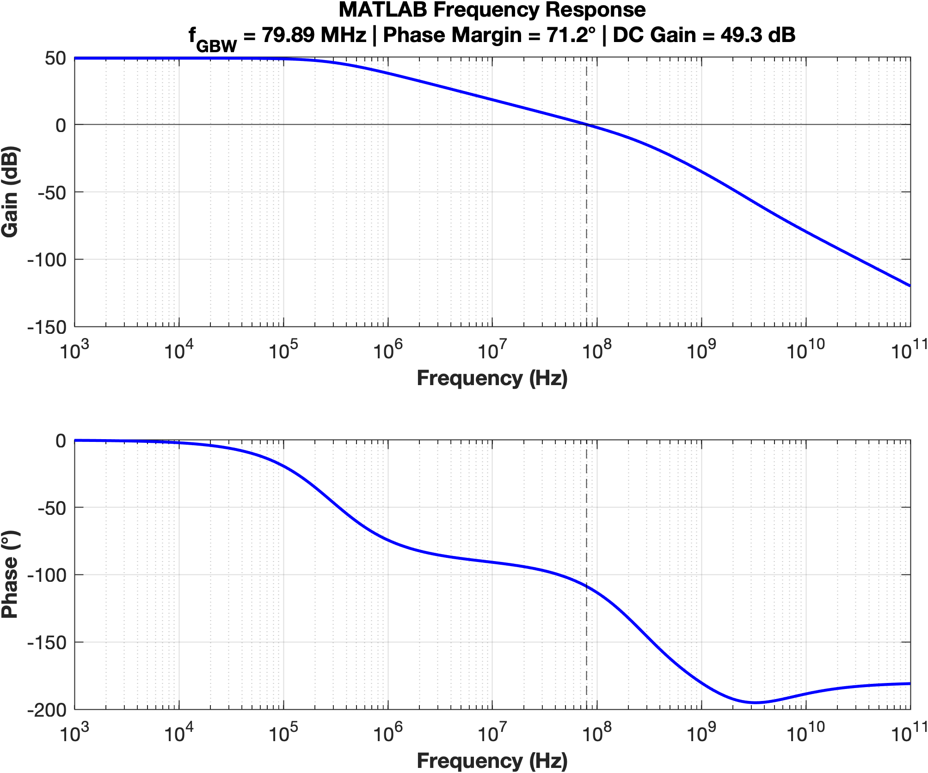
Figure 13: $Bode plot of Matlab$

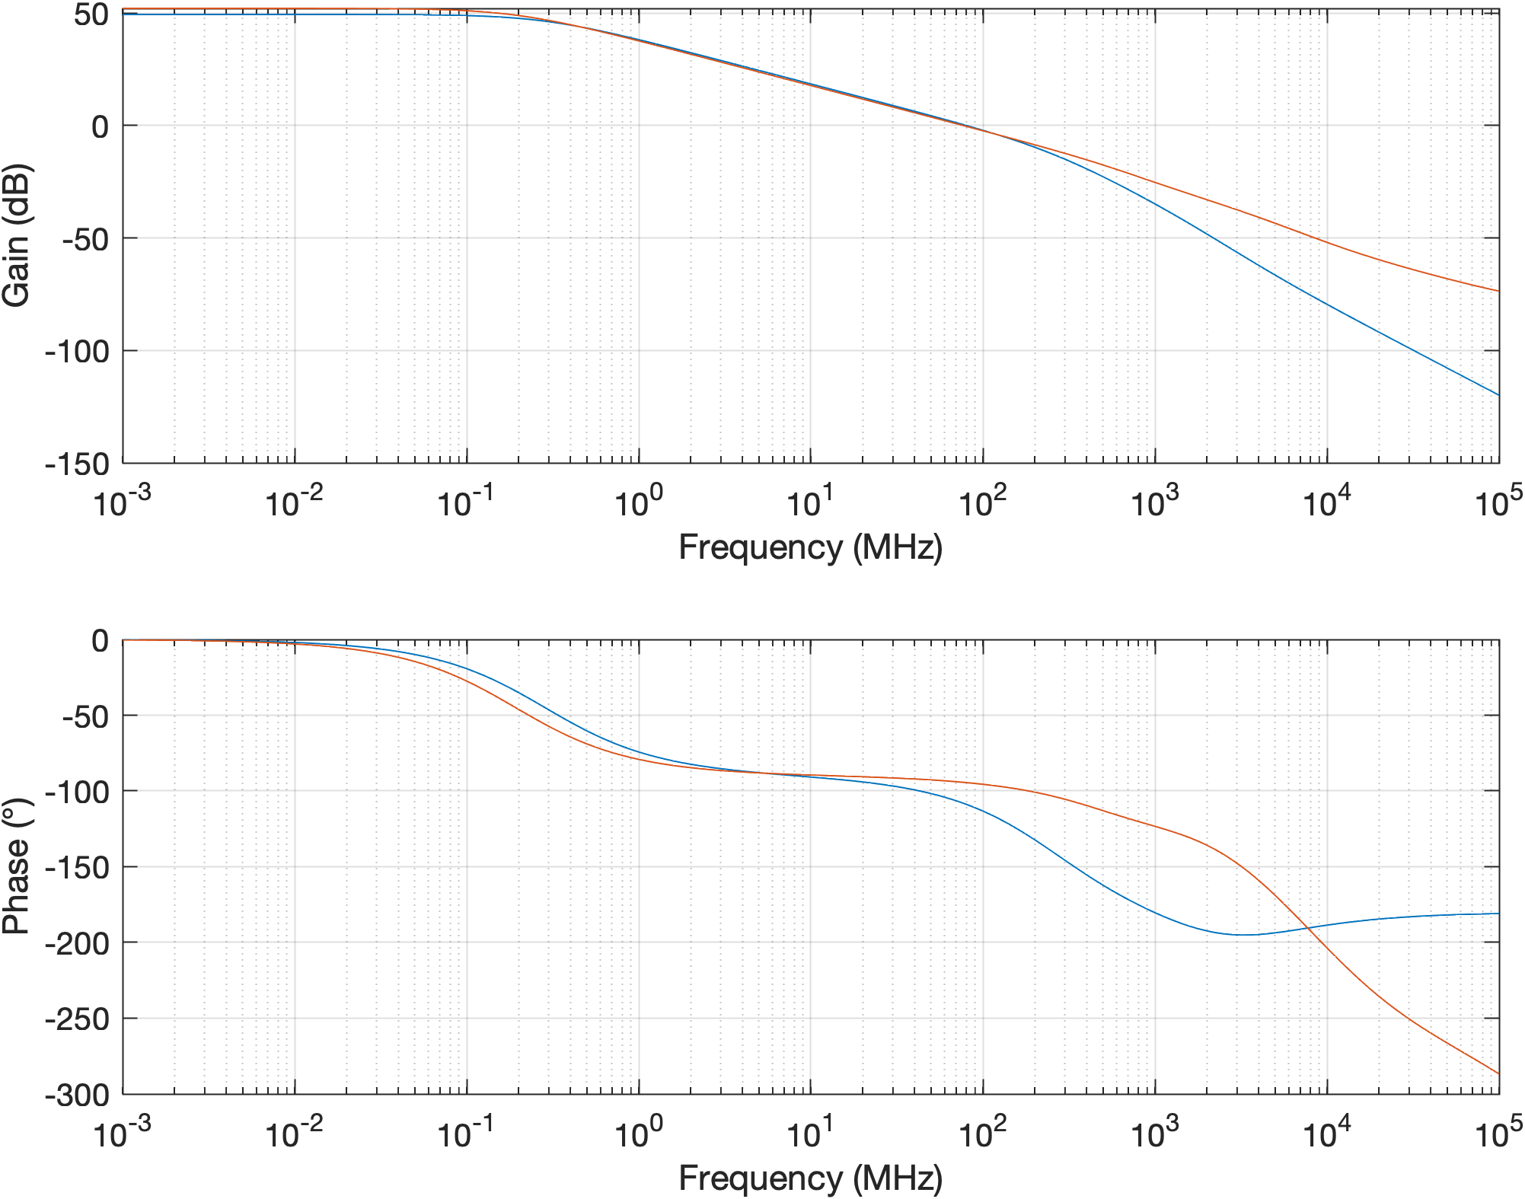

Figure 14: Full Bode Comparison

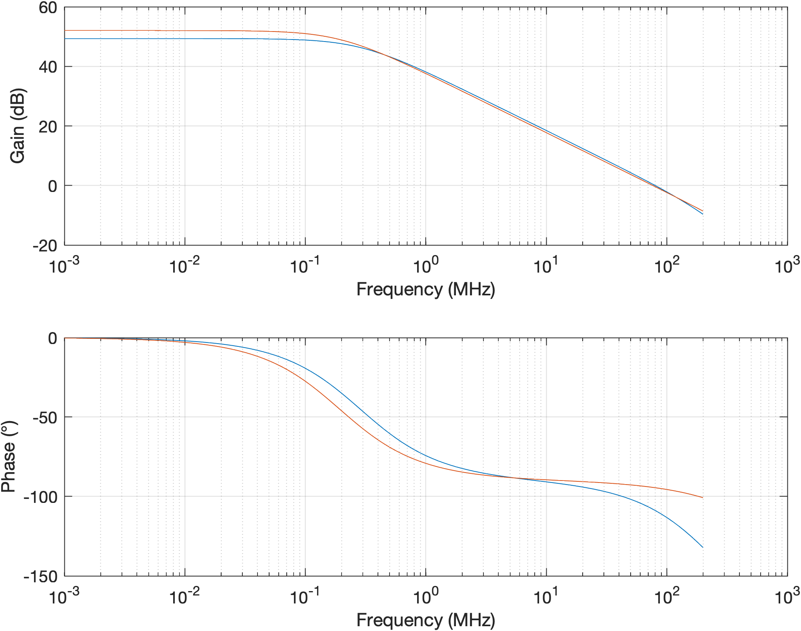

Figure 15: Zoomed-in Bode Comparison

Simulator | PM (deg)
MATLAB | 71.2
LTspice | 85.7

Explain, analyse and interpret the results above. Furthermore, if you observe significant differences between MATLAB and LTspice, explain why.

Both simulators confirm the amplifier successfully meets the design specifications for the PM( >70°), DC gain(>48dB). The Bode plots display a standard two-stage response: constant DC gain followed by a -20 dB/decade roll-off. The phase plot demonstrates that the nulling resistor ($R_{M}$) successfully move the Right-Half-Plane(RHP) zero into the LHP, compensating for the non-dominant pole and ensuring robust stability.

Deviations Between Simulators :
While both pass, LTspice yields higher performance metrics than MATLAB, notably in DC gain ( 52 dB vs 49 dB), and Phase Margin (85.7° vs 71.2°), and a lower $f_{GBW}$ (76.36 MHz vs 79.89 MHz),. These deviations stem from three main differences in how the software calculates the circuit:
- Device Modeling: MATLAB relies on static Look-Up Tables (LUTs) at fixed voltages, whereas LTspice uses dynamic BSIM4 models that actively calculate short-channel effects, slightly altering the actual transconductance(gm) and output resistance(gds), making a higher gain possible ( 52dB) .
- Parasitics: MATLAB uses lumped approximations for parasitic capacitance, while LTspice simulates exact voltage-dependent junction capacitances, which shifts high-frequency pole locations( affecting fGBW).
- Zero Placement: The physical shift in the second-stage transconductance ($g_{m6}$) in LTspice slightly moves the exact frequency of the compensating zero, providing the extra phase lead observed in the simulation.

Change the “.temp” directive in LTspice to 27, 90 and -190 and fill in the table below. This simulates the circuit at different temperatures in $°C$.
Simulator | $$27°C$$ | $$90°C$$ | $$-190°C$$
Gain[dB] | 52 | 50.8 | 52.7
$f_{GBW}$[MHz] | 76.36 | 70.02 | 177.63
Discuss:
At 90°C, the Gain-Bandwidth Product ($f_{GBW}$) drops from 76.36 MHz to 70.02 MHz. This occurs because higher temperatures reduce carrier mobility ($μ)$, leading to a lower transconductance for a fixed bias current. The DC gain also drop slightly at 50.8 dB, because the drop in $g_{m}$ lower the total intrinsic gain product ($g_{m}r_{0}$).
At -190°C (cryogenic conditions), the $f_{GBW}$ spikes massively to 177.63 MHz. This is driven by a huge increase in carrier mobility, which heavily boosts $g_{m}$. Hence, the DC gain reach 52.7 dB. While $g_{m}$ increases, the threshold voltage($V_{th})$ also shifts at extreme cold temperatures, which degrades $r_{0}$. Because the reduction in $r_{0}$ is far less severe than the boost in $g_{m}$, the overall gain product increase at the cost of losing our $f_{GBW}$ target.

Simulate $A_{v}$ in LTspice for the following cases:

No compensation network ($C_{M}=R_{M}=0$).

With compensation capacitor but no compensation resistor ($R_{M}=0$).

With both the compensation capacitor and the compensation resistor.

Then, show all 3 cases in seperate plots such that the differences are clearly visible. Furthermore, indicate on each plot the resulting PM.

Plot:

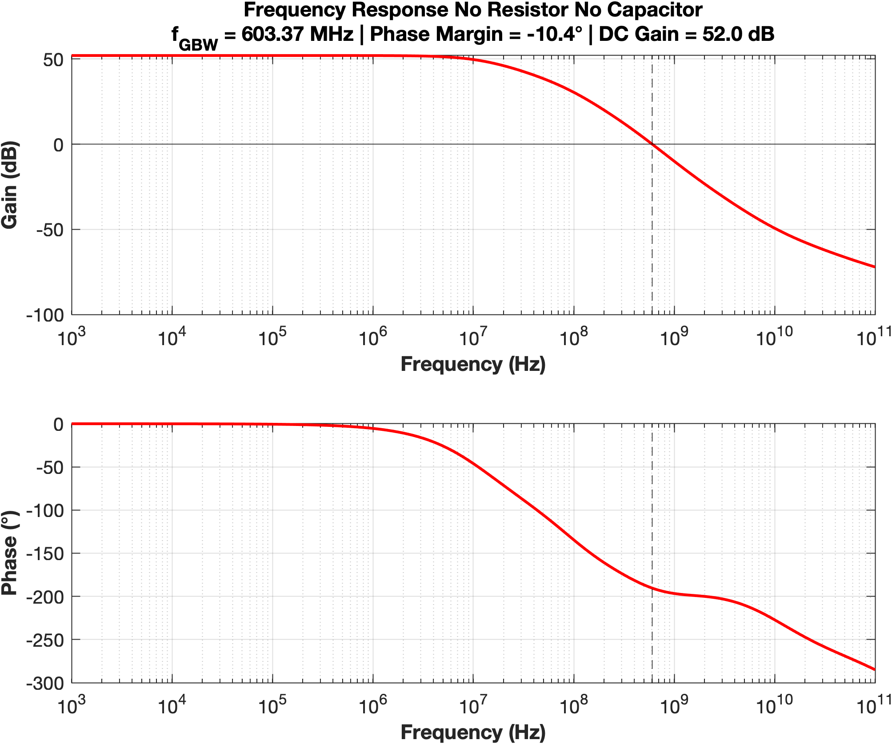

- Figure 16: Bode plot, No Compensation Network $R_{m}=C_{m}=0$

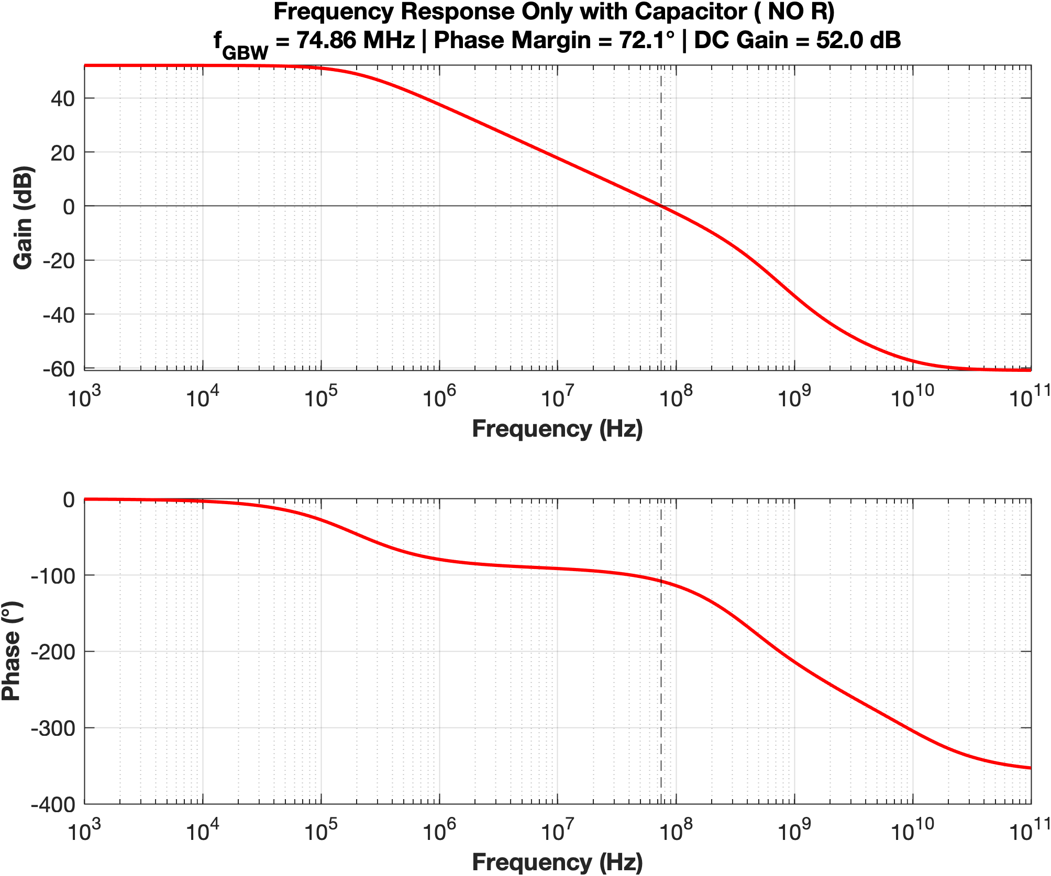
- Figure 17: Bode plot with Compensation capacitor only ($R_{m}=0)$

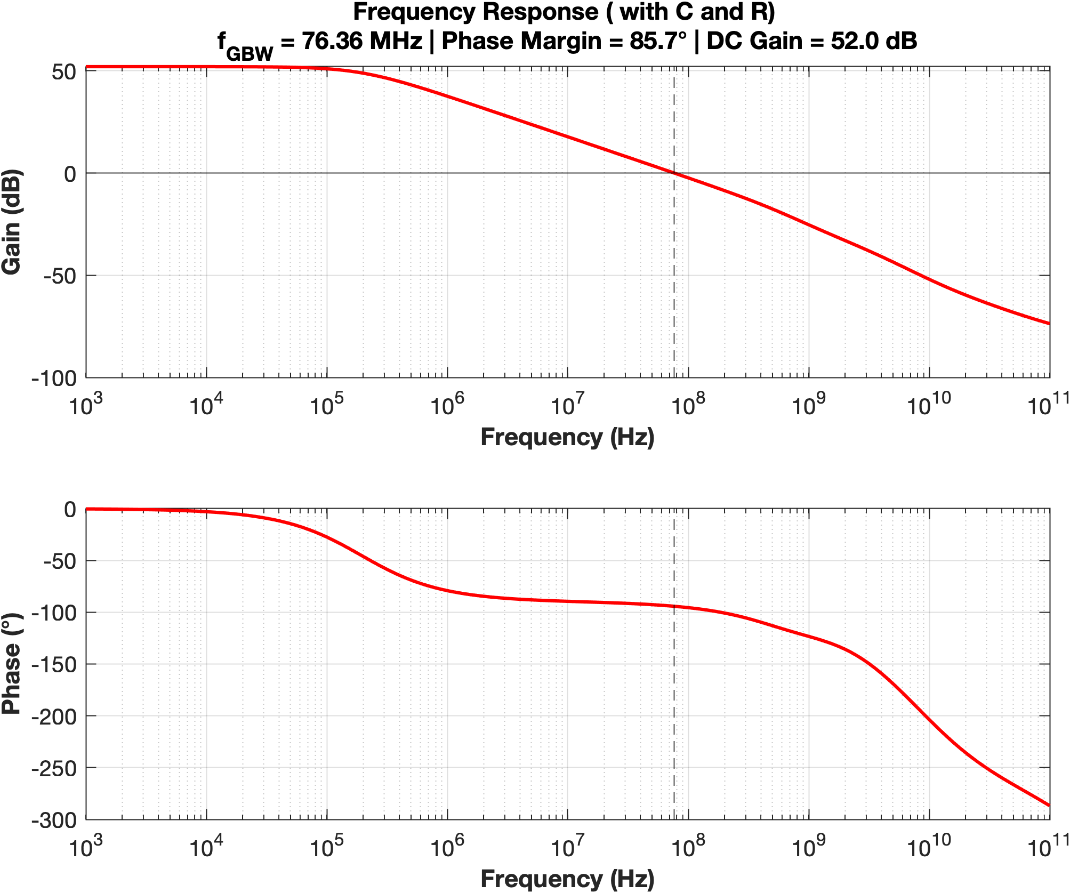
c) Figure 18: Bode plot with Compensation capacitor and resistor

Case | PM [deg]
No compensation network | -10.4
No compensation resistor | 72.1
With both compensation components | 85.7

Explain, analyse and interpret the results above (for each case, explain the effect it has on the plots and PM.
• No compensation network (PM = -10.4°): Without compensation, the poles of the first and second stages are located closely together at relatively low frequencies. This causes the gain to roll off at -40 dB/decade while crossing the 0 dB axis, accumulating nearly -180° of phase shift. The resulting -10.4° phase margin indicates that the uncompensated system is highly unstable.
• No compensation resistor (PM = 72.1°): Adding the Miller capacitor ($C_{m}$) introduces pole-splitting. The dominant pole is pushed to a much lower frequency, establishing a stable -20 dB/decade roll-off, which drastically improves the phase margin to 72.1°. However, the feedforward path through $C_{m}$ creates a Right-Half Plane (RHP) zero.
• With both compensation components (PM = 85.7°): The addition of the nulling resistor ($R_{m}$) in series with $C_{m}$successfully shifts the problematic RHP zero into the Left-Half Plane (LHP). In the LHP, the zero provides a phase lead that is designed to directly cancel the phase lag of the non-dominant output pole ($p_{3}$). This compensation yields a highly stable phase margin of 85.7°.
It is worth noting that increasing the nulling resistor from 210$Ω$to 300$Ω$ improves the $f_{GBW}$from 76.36MHz( see figure 18) to the targeted 80MHz. But this change only applies after trying the LTSpice simulation.

- Noise contribution in LTspice

Simulate the output-referred noise voltage power density ${\overline{dv_{out,eq}^{2}}}/{∆f}$ over an appropriate frequency range in LTspice. Then, insert the ${\overline{dv_{out,eq}^{2}}}/{∆f}$-plot below (use a logarithmic plot).

Plots:

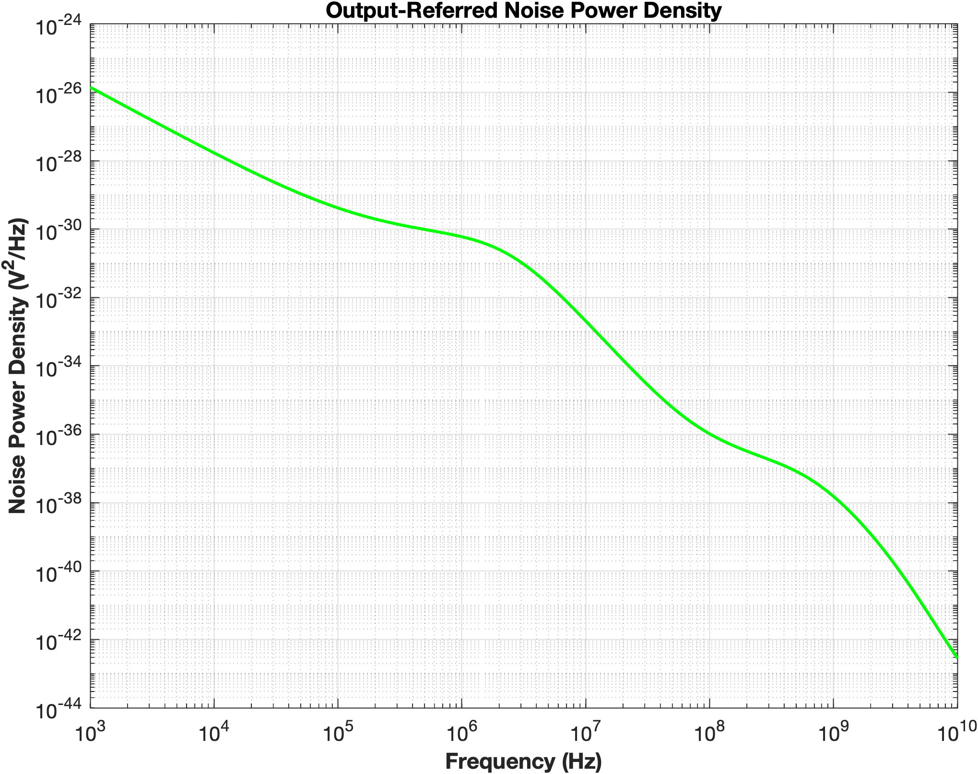

Figure 19: Output-Referred Noise Power Density ($dv_{out,eq}^{2}/Δf$)

Explain, analyse and interpret the results above (what regions can you see in the plot, and why?).
The output-referred noise spectral density exhibits three distinct regions. At low frequencies, the spectrum is dominated by flicker (1/f) noise, which decreases with increasing frequency due to its inverse frequency dependence. As the frequency increases, thermal noise becomes the dominant noise source. Beyond the dominant pole of the amplifier (approximately 271 kHz), the amplifier gain begins to roll off, causing the output-referred noise to decrease with frequency. Around the non-dominant output pole (approximately 360 MHz), the attenuation becomes even stronger, resulting in a steeper decline of the noise spectrum at high frequencies. Consequently, the amplifier itself acts as a low-pass filter, limiting the output noise bandwidth.

Simulate the input-referred noise spectral density by using the .NOISE option in LTspice. Also, by using LTspice, determine the total output integrated noise of the OpAmp. For that, take the integration bandwidth from $10$ kHz to $10⋅f_{GBW}$. Furthermore, copy and paste the top 9 contributing elements using "View->SPICE Error Log" option and insert that list below.

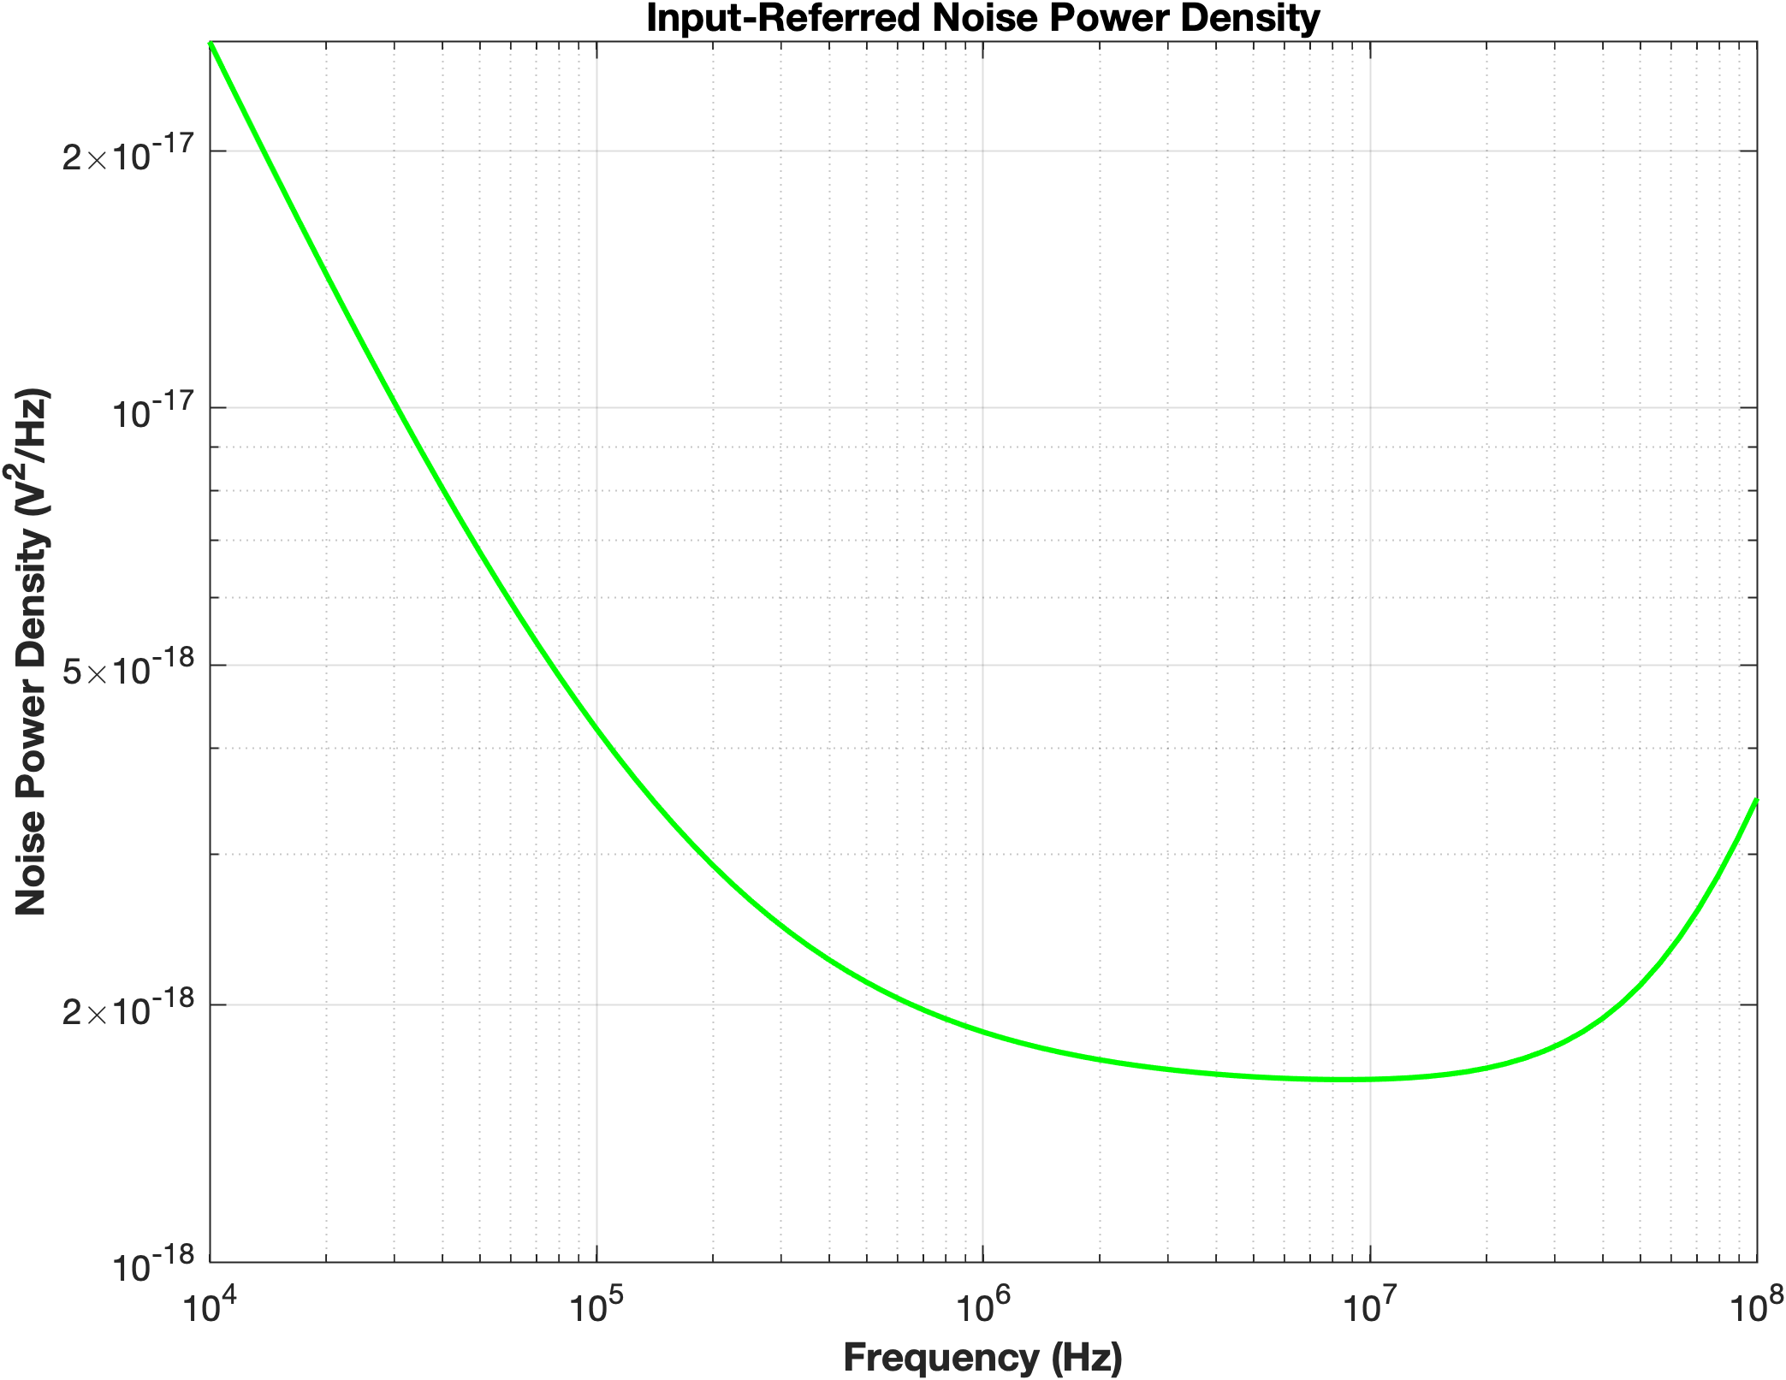

Figure 20: Input-Referred Noise Power Density ($dv_{out,eq}^{2}/Δf$)

Top 9 :
out_mn4nvrms: INTEG(V(mn4) )=3.93633125585e-05 FROM 10000 TO 800000000
out_mn3nvrms: INTEG(V(mn3) )=3.59774137402e-05 FROM 10000 TO 800000000
out_mp2nvrms: INTEG(V(mp2) )=2.02746428659e-05 FROM 10000 TO 800000000
out_mp1nvrms: INTEG(V(mp1) )=2.02235482769e-05 FROM 10000 TO 800000000
out_totnvrms: INTEG(V(onoise) )=6.28137907659e-05 FROM 10000 TO 800000000
out_mp7nvrms: INTEG(V(mp7) )=2.32779619373e-06 FROM 10000 TO 800000000
out_mn6nvrms: INTEG(V(mn6) )=5.16816023944e-06 FROM 10000 TO 800000000
out_mp8nvrms: INTEG(V(mp8) )=6.21860342684e-06 FROM 10000 TO 800000000
out_mp5nvrms: INTEG(V(mp5) )=1.54146043545e-06 FROM 10000 TO 800000000

total output integrated noise :
$$6.28×{10}^{-5}{\text{ V}}_{\text{rms}}$$

(out_totnvrms: INTEG(V(onoise) )=6.28137907659e-05 FROM 10000 TO 800000000)

Explain, analyse and interpret the results in above (what regions can you see in the plot, and why? + why is every transistor ranked the way it is for noise contribution).

The input-referred noise density shows the expected three regions: a 1/f-dominated fall-off at low frequency, a shallow minimum around the low-MHz range where thermal noise briefly dominates( creating a kind of “plateau”), and a rise at high frequency caused by the LTspice Sᵢₙ=Sₒᵤₜ/|A(f)|² division artifact as the amplifier's gain rolls off.

The input differential pair (Mn3 and Mn4) dominates because its noise is generated directly at the amplifier input and is amplified by the full gain of both stages. The PMOS load devices (Mp1 and Mp2) also contribute significantly because they are connected to the high-gain first stage. The second-stage transistors (Mn6 and Mp5) contribute less since their noise is not amplified by a preceding gain stage. Finally, the bias transistors (Mp7 and Mp8) contribute very little because they mainly establish the DC operating point
Since the first-stage gain ($A_{v1}$=15.3) is slightly lower than the second-stage gain ($A_{v2}$=19.3), the second-stage noise is somewhat less attenuated than in a conventional two-stage OTA. Nevertheless, the first stage remains the dominant noise source. The rationale for this gain distribution is discussed in the Final Stage 1 Gain Verification section.

Also copy and paste the total integrated noise (out_totnvrms) when simulated at $90°C$ and $-190°C$. Compare these to the one at $27°C$ and discuss.

27°C :
$$6.28×{10}^{-5}{\text{ V}}_{\text{rms}}$$

out_totnvrms: INTEG(V(onoise) )=6.28137907659e-05 FROM 10000 TO 800000000

90°C :

$$4.52×{10}^{-5}{\text{ V}}_{\text{rms}}$$
out_totnvrms: INTEG(V(onoise) )=4.52599425142e-05 FROM 10000 TO 800000000

-190°C :
$$6.55×{10}^{-5}{\text{ V}}_{\text{rms}}$$

out_totnvrms: INTEG(V(onoise) )=6.55515885387e-05 FROM 10000 TO 800000000

Although thermal noise is theoretically expected to increase with temperature, the simulated output-referred noise decreases at 90°C and increase at −190°C compared to 27°C.
At 90°C $\left(4.52×{10}^{-5} V_{rms}\right)$, reduced carrier mobility and threshold-voltage shifts modify the bias conditions, lowering the amplifier gain and bandwidth. As a result, the first-stage noise experiences less amplification, leading to a lower output-referred noise.
At −190°C $\left(6.55×{10}^{-5} V_{rms}\right)$, thermal noise is expected to decrease at cryogenic temperatures, the BSIM transistor models are not fully validated in this operating region. In addition, changes in threshold voltage, mobility, bias point, and frequency response modify how individual noise sources are transferred to the output. Consequently, the simulated increase should be interpreted as a model-dependent result rather than a physical trend.

- Linearity

Explain why gain compression occurs when you increase the input voltage.
As the input voltage increases, key transistors are driven out of saturation into the triode or cutoff regions. This causes their transconductance to drop significantly, leading to a collapse in overall small-signal gain ( called gain compression). Additionally, because the output voltage is physically bounded by the supply rails ($V_{DD}$ and $V_{SS}$), large signal swings result in waveform clipping, preventing any further increase in output amplitude.

When given an operating point (biasing of the transistors), which is the ideal input voltage range of operation?hen given an operating point (biasing of the transistors), what is t
The ideal input voltage range is the input common-mode range (ICMR), where all transistors remain in saturation and the amplifier operates linearly. For this design:
$$227mV≤V_{CM,in}≤587mV$$

What happens to the gain if the input signal falls out of the linear region previously stated?

If the input exceeds the linear range, one or more transistors leave saturation, causing the amplifier gain to decrease significantly. The output becomes nonlinear and may eventually saturate or clip.

Conclusion (10 points):

Conclude your experiment by filling the editable fields in the performance table depicted below

Metric | Units | Specification | from  hand-calculations | MATLAB | LTspice
DC gain | magnitude | 251.2 | 295 | 291.7 | 512.86
DC gain | dB | 48 | 49 | 49.3 | 54.2
Gain-Bandwidth frequency $f_{GBW}$ | MHz | 80 | 79.9 | 79.9 | 76.36
Dominant pole frequency $f_{dom}$ | kHz | 271.11 | 270.9 | 285.9 | 192
PM | ° | > 70 | 74.6 | 71.2 | 85.7
$$V_{in,cm,max}-V_{in,cm,min}$$ | V |  | 0.360 | 0.363 | 0.361
$$V_{out,max}-V_{out,min}$$ | V | > 0.7 | 0.8 | 0.8 | 0.8
$$P_{diss}$$ | mW |  | 2 | 2.2 | 2.195
$\overline{v_{out,eq}^{2}}$ (output-referred noise) | V_{rms} |  |  |  | 1.2458e-10

Comment about the deviations between hand calculation, MATLAB and LTspice values found above. Conclude, what the causes of such deviations are.
Values obtained by hand calculations neglected several capacitances, and used ideal assomptions in the report such as $V_{dsat}=V_{OV}$ while in reality such voltage were different.

Matlab results are closer to handcalculations, but to hit the Gain-Bandwith frequency, i had to set the target higher ( 84MHz) which resulted in a higher transconductance ($g_{m}$) than in handcalculation. Therefore getting a slighty higher DC gain.
For LTSpice, the result are much more diverse for the phase margin and the gain bandwidth frequency, this can be explained by the different models used between matlab and LTSpice
This lead to deviation in the DC gain and Gain frequency Bandwidth, still above the target of the design.

If you have results which are not passing the specifications: conclude for each of those result what the cause is and what you need to do in order to make it pass, if you were repeating this experiment.
All the results from both MATLAB and LTspice were satisfactory. The only significant issue was the lower gain-bandwidth frequency obtained in LTspice. This was resolved by increasing the nulling resistor ($R_{m}$) from 221 Ω to 300 Ω, which effectively shifted the gain-bandwidth frequency to the target value of 80 MHz.
One thing I noticed is that I maximized the gain of the first stage by using a transistor length of L = 1000 nm. As a result, the second stage ended up having a higher gain than the first stage in order to meet the overall gain specification. A different design approach could potentially improve this by increasing the gain of the first stage relative to the second stage, which would also reduce the overall noise. However, I am not certain that such a design would still satisfy all the required specifications.
The only disappointing result is that I had to set the input common-mode voltage, (V_{in,CM}), to 0.5 V, which is not exactly at the midpoint of the input voltage swing. When I moved it closer to the midpoint (around 0.4 V), the DC gain dropped to approximately 41 dB. This reveals a trade-off between DC gain and input voltage swing, which could be investigated further in a future redesign of this OTA.
Overall, I consider this project a success, and I would like to thank Professor Piet Wambacq and his TAs for giving us the opportunity to work on such an interesting and educational project.

Appendix:
Previously, you were expected to include your MATLAB code and LTspice netlist here, but now we changed it so that you must upload them in the Canvas assignment. Read the description of the assignment for details on exactly what files are needed!

